**RTCQI LOGBOOK**

ADMINISTRATOR USER GUIDE

**Dashboard**

Provides a quick snapshot

* Over all Audits.
* Number of Audits(Last 12months).
* Number of Sites Audits(Last 12months).
* View map based on the sites.
* View Recent Monthly Logbook Entries.

By default, the dashboard map shows data for the last 30 days, but this can be easily changed by adjusting a date range and choose province in the field above the screen. Below the map we show the monitoring sitewise reports and the total count of email sitewise.Below the monitoring sitewise reports, shows 10 latest logbook entries. Then we show bar graph for monthly reports last 12 months. Then We show the bar graph sitewise last 12 months.

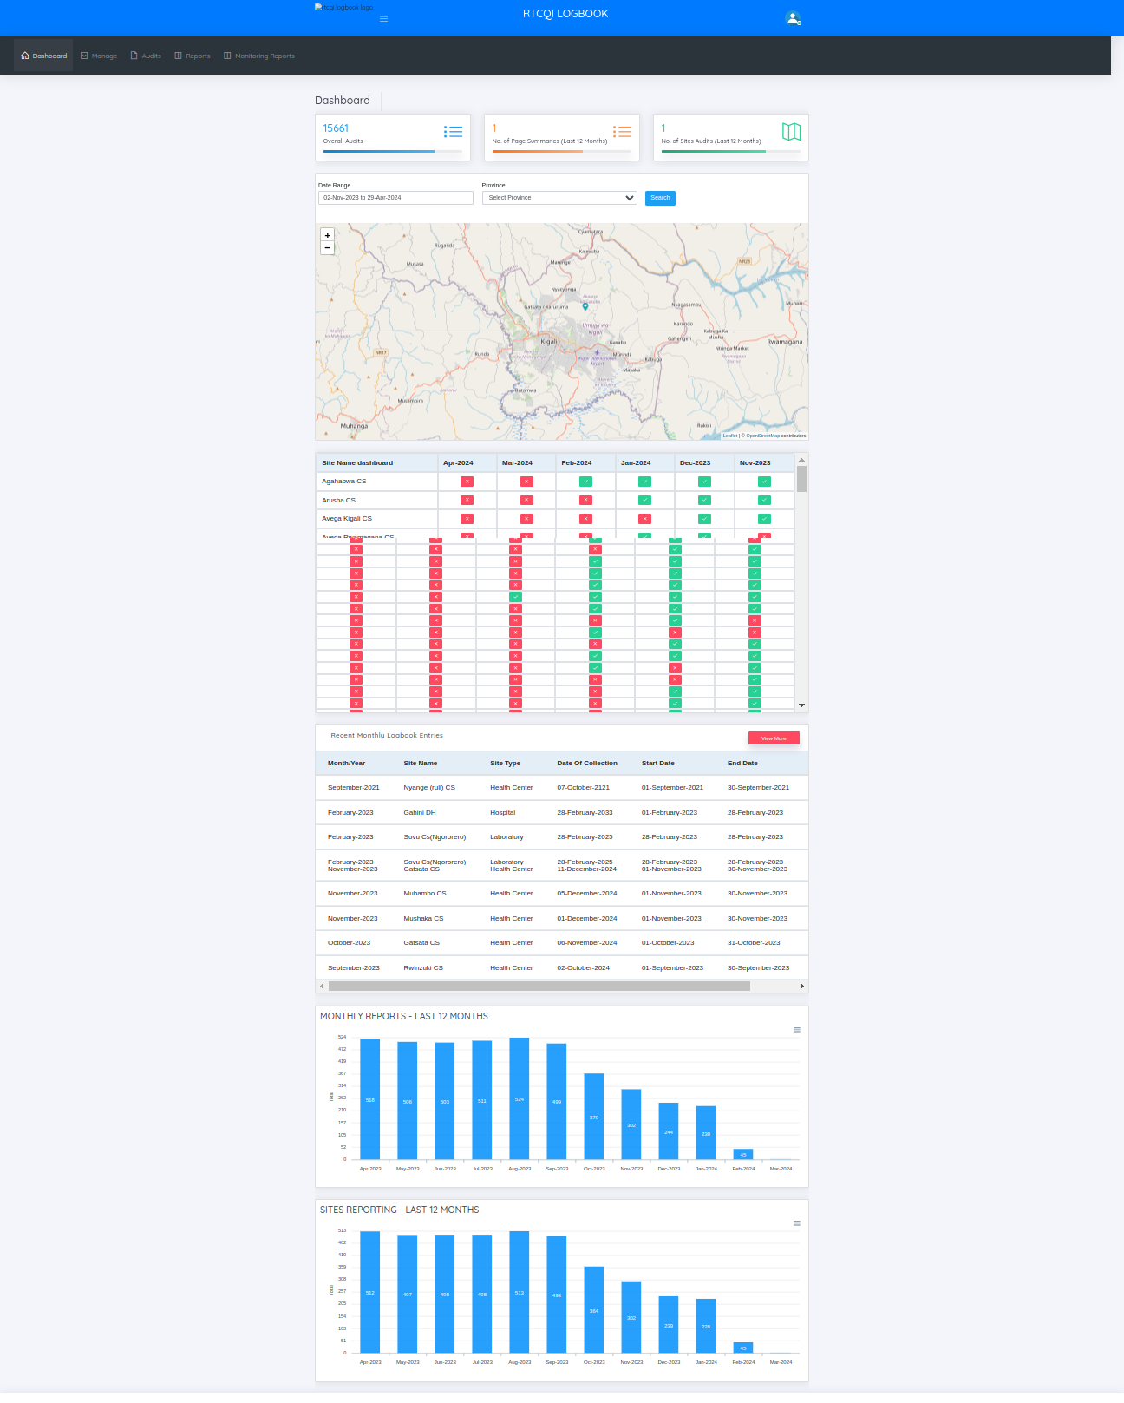

**Manage Menu**

This menu has the list of functionalities that are typically managed by the System Administrator (or simply, Admin)

Admin can modify users, global configuration.

* Access Control
  + Users
  + Roles
  + User Login History
  + User Activity Log
* Test Sites
* Locations
  + Provinces
  + Districts
  + Sub Districts
* Global Config
* Entry Point / Site Type
* Test Kits
* Allowed Test Kits
* Audit Trail
* Implementing Partners

**ROLES**

RTCQI LogBook uses Role-based access control (RBAC) to restrict access to authorized users. Administrators can define roles with specific permissions and assign those roles to users.

On the Roles page, administrator can:

* + View roles
  + Add role
  + Edit role

Add and Edit Role pages allow admin to create or edit roles respectively. On these pages, the admin can :

* + Enter a unique Role Name, Role Code, Default Landing Page, Status (active/inactive)
  + Check/uncheck privileges (only checked privileges are allowed for the users having this role)

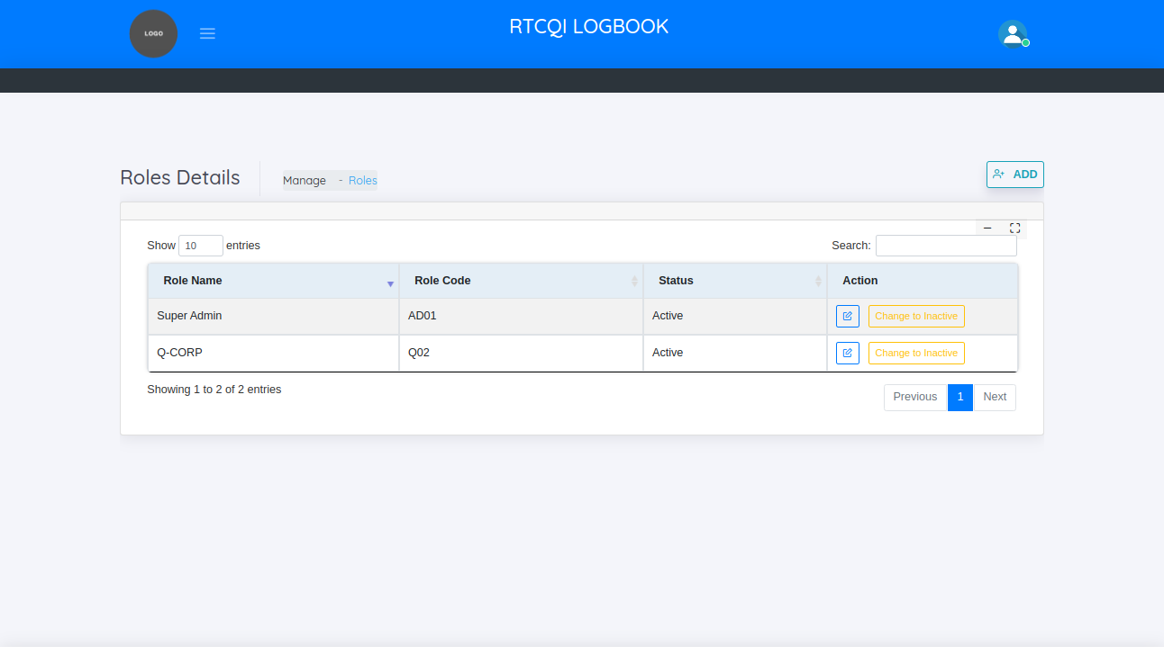

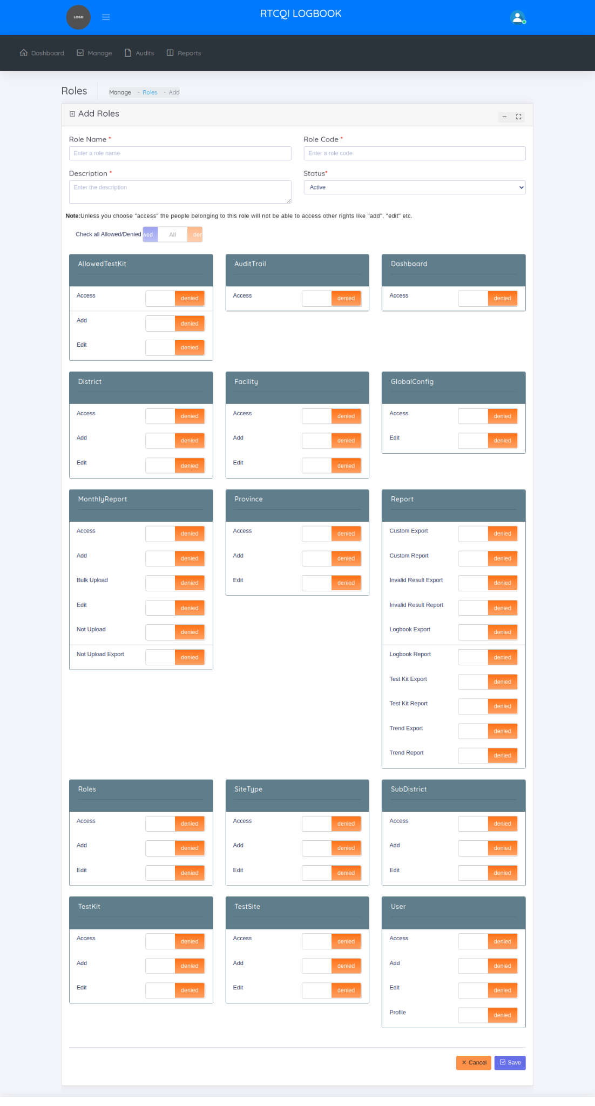

**USERS**

RTCQI LOGBOOK requires each user to have a separate login. Only the RTCQI LOGBOOK administrator can create users. This allows the admin to only allow authorized users to log in to the application.

On the Users page, administrator can:

* + View users
  + Add new user
  + Edit user

Add and Edit Users pages allow admin to create or edit users, respectively. On these pages, the admin can :

* + Enter the User’s First Name, Last Name, Password ,Confirm Password(Password must be at least 6 characters long and must include AT LEAST one number, one alphabet and one special character) ,Mobile Number, Email(Login ID), User Status(Active/Inactive), Role, Test Site User Map Details
  + The Login ID and Password entered here are to be shared with the users, which they can use to log into RTCQI Log Book
  + Two Types of Mapping

1.Sitewise Mapping

2.LocationWise Mapping

**Site-Wise Mapping**

* + Admin can map the sites to the user. mapped sites only the user allow to create the monthly report
  + We can filter the mapped sites, on the basis of province name, district name, sub district name.

**Location-Wise Mapping**

* + Admin can map the location to the user. Mapped location sites only the user allow to create monthly report

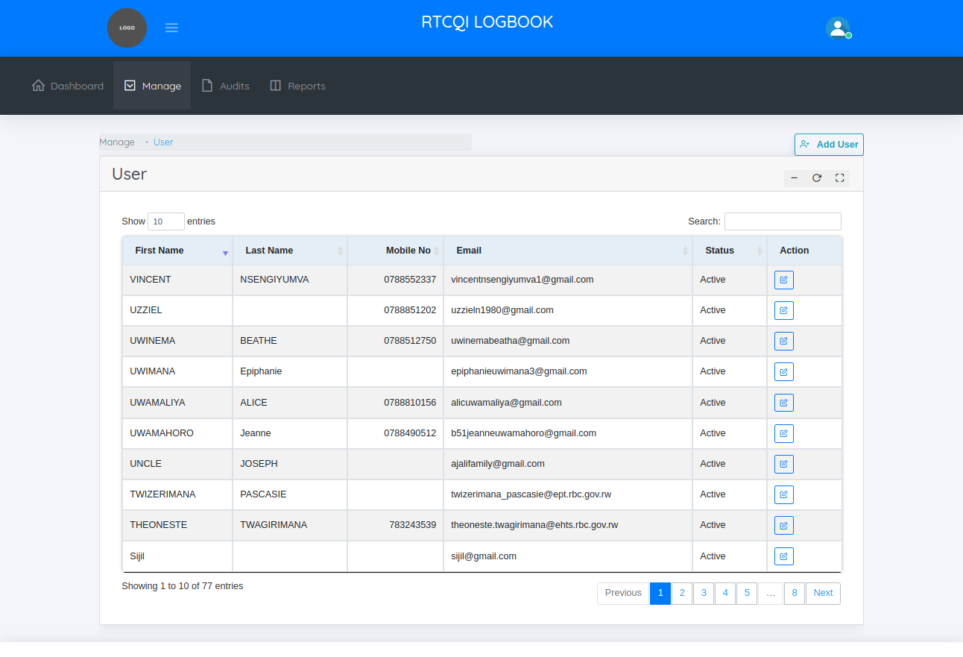

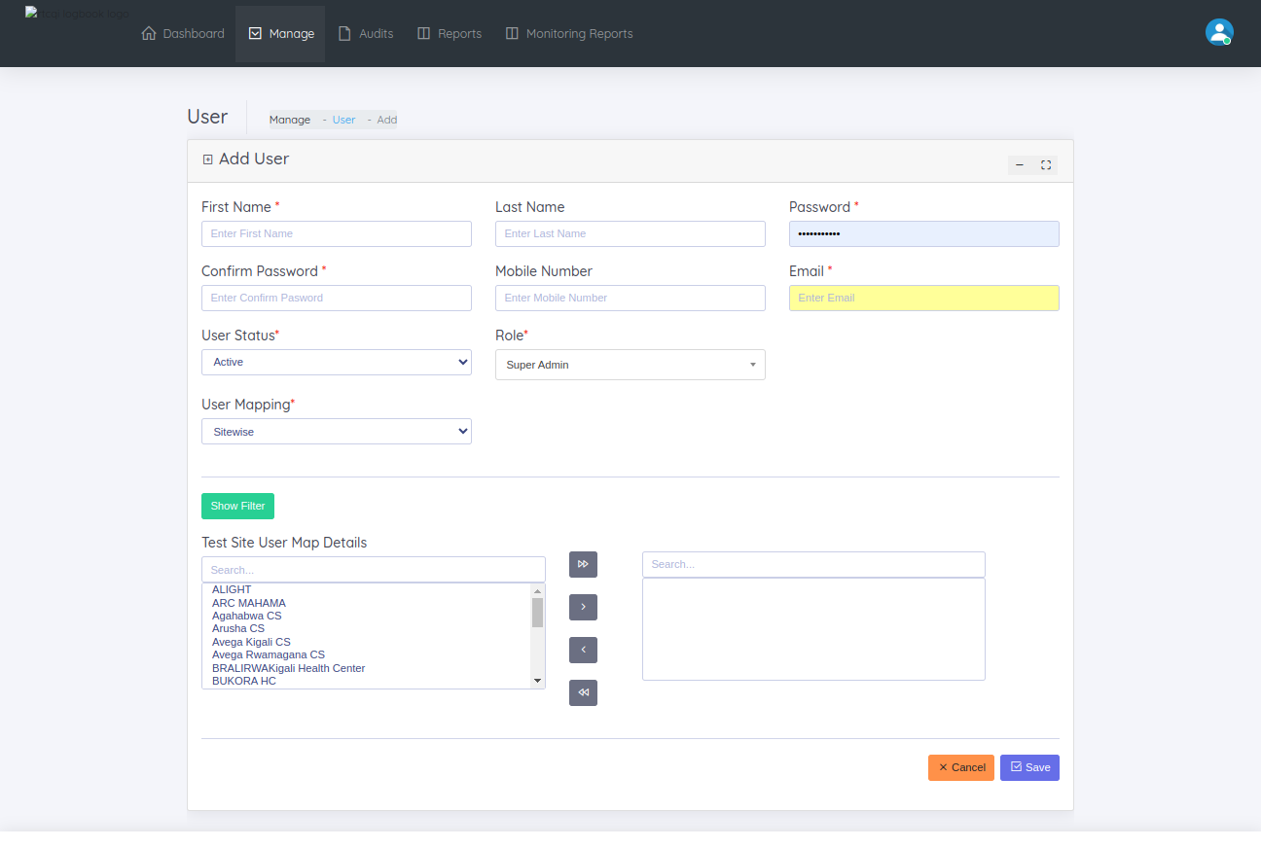

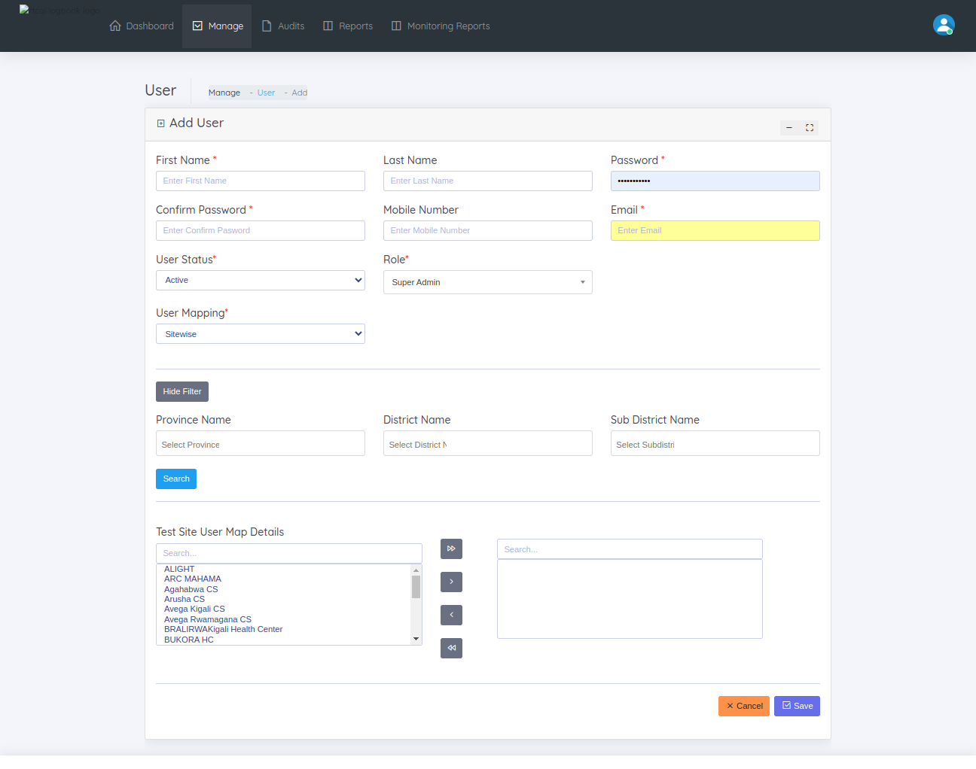

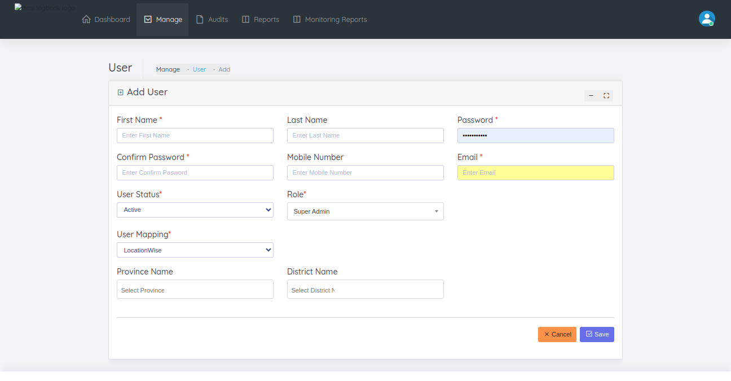

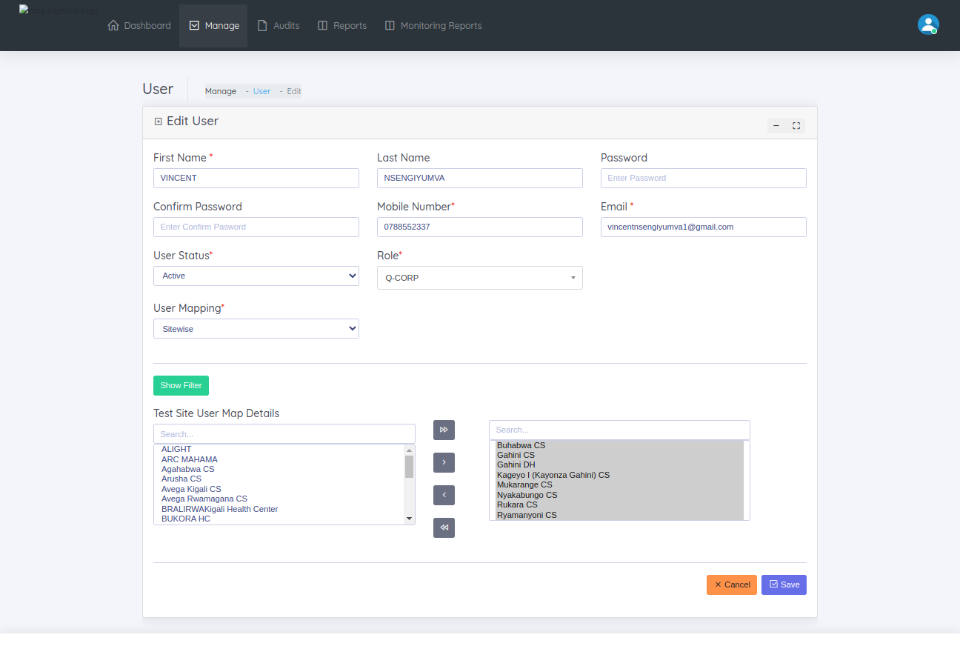

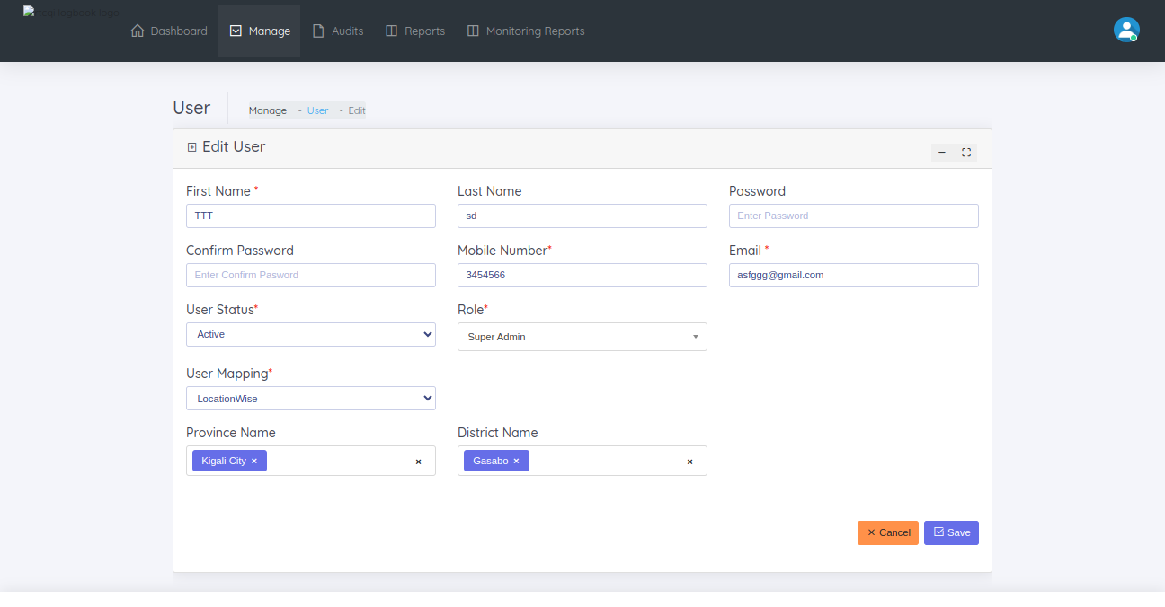

**USER LOGIN HISTORY**

This page helps to manage the user login histories. When the user login/logout that details show this page. Show the following columns in this page

* + Login Attempt Date & Time
  + Username
  + Login ID
  + IP Address
  + Browser
  + Operating System
  + Login Status

Two Filters added such as Date range , user name to filter the login/logout details in this page.

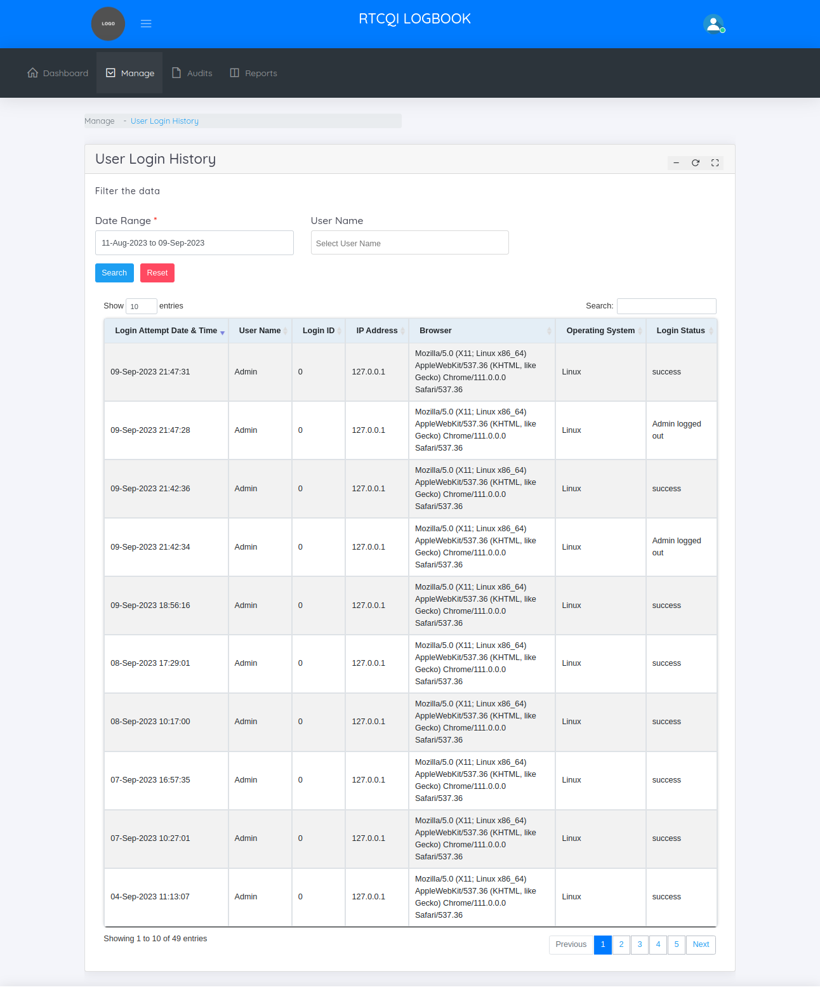

**USER ACTIVITY LOG**

This page helps to manage the user activity of entire application. When the user add, edit, and change anything , that details track and show this page following columns show this page.

* + Event Type
  + Action
  + Resource
  + IP Address
  + Date Time

Two Filters added such as Date range , user name to filter the user track details of entire application in this page

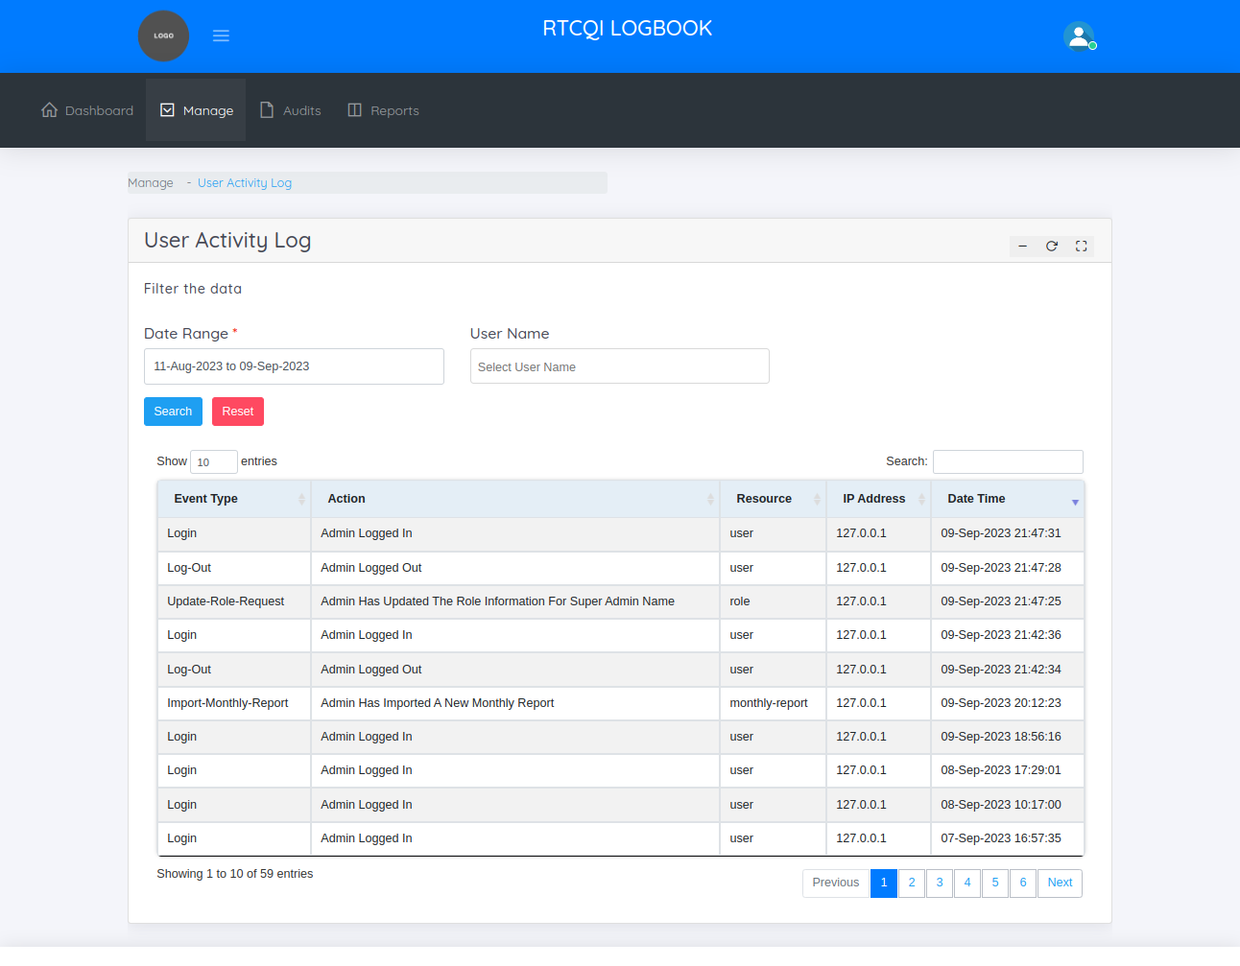

**TEST SITES**

Test Site refers to the specific location.

On the Test Sites Page, the administrator can:

* + View test sites
  + Add new test sites
  + Edit test sites

When add the test sites check the locations to the user location mapping tables , if match the location, then take the users and then inserted users with the test site id to user testsite mapping table.

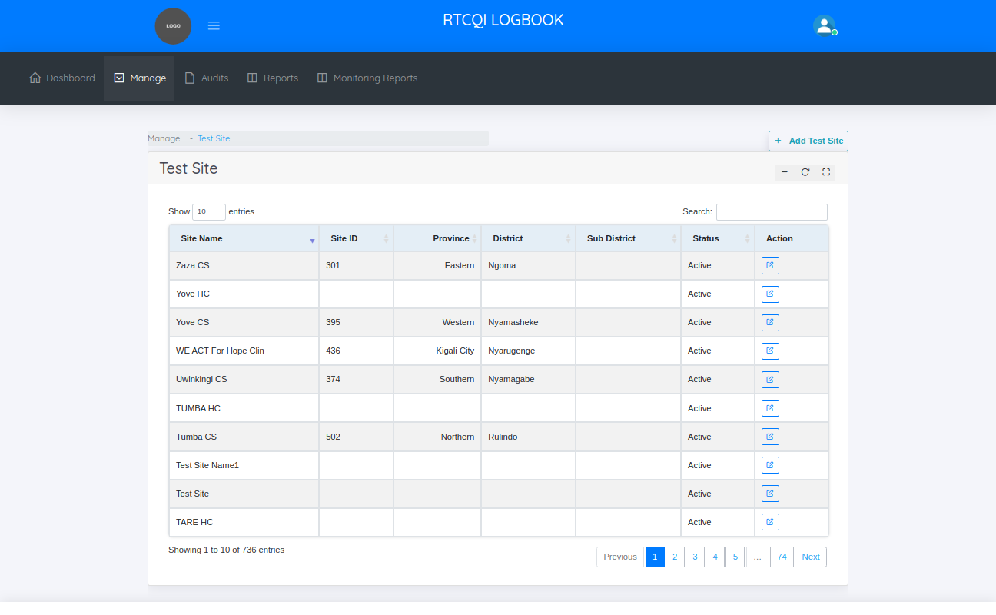

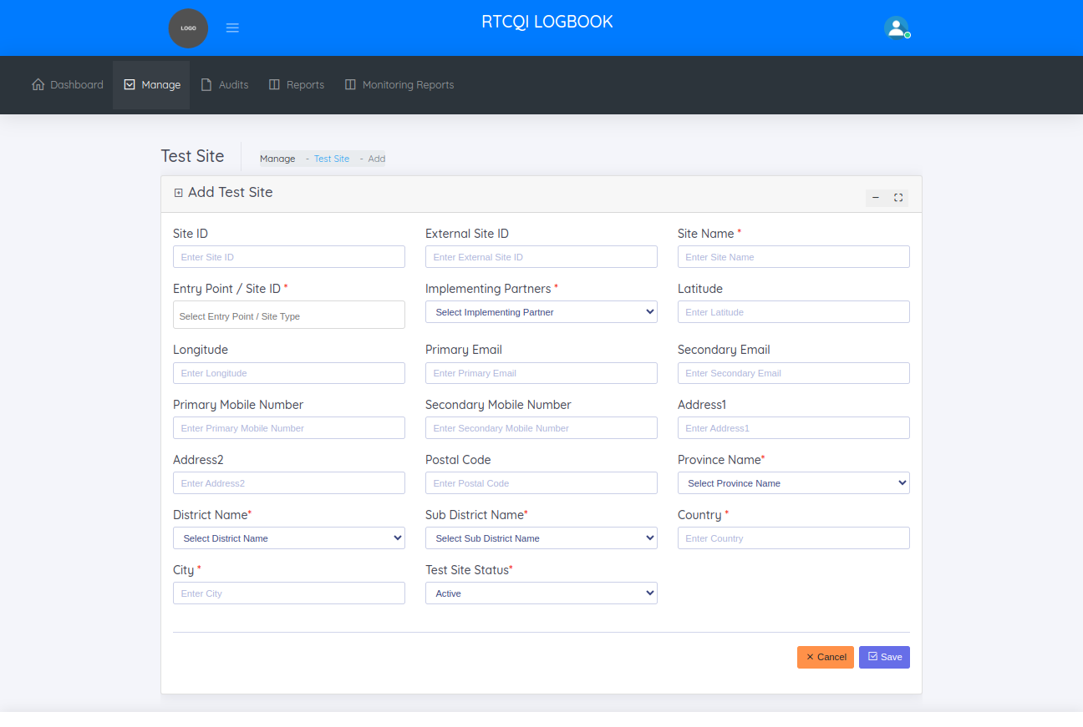

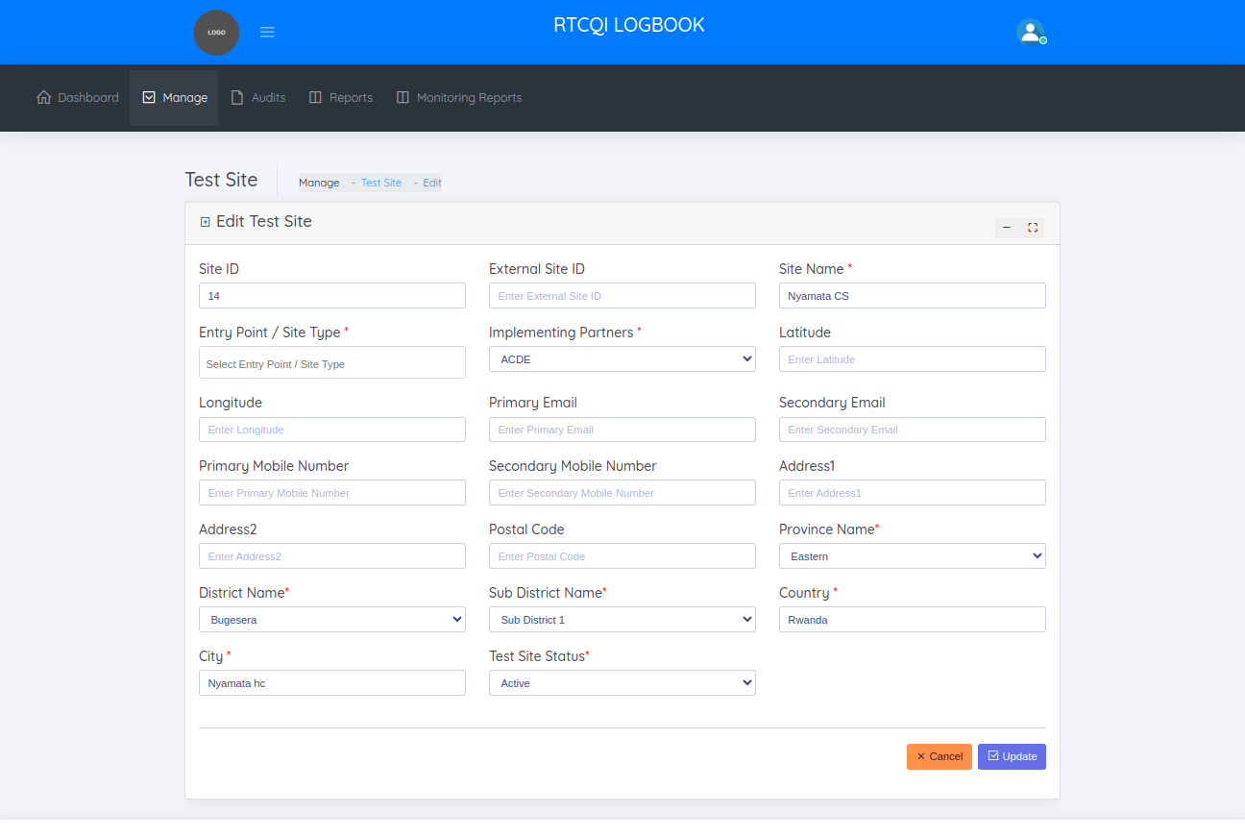

**LOCATIONS**

In Locations menu, there are 3 categories

* + Province
  + District
  + Sub District

**PROVINCE**

The Province page helps to manage the provinces across the country

On this page, administrator can:

* + View provinces.
  + Add New province.
  + Edit province

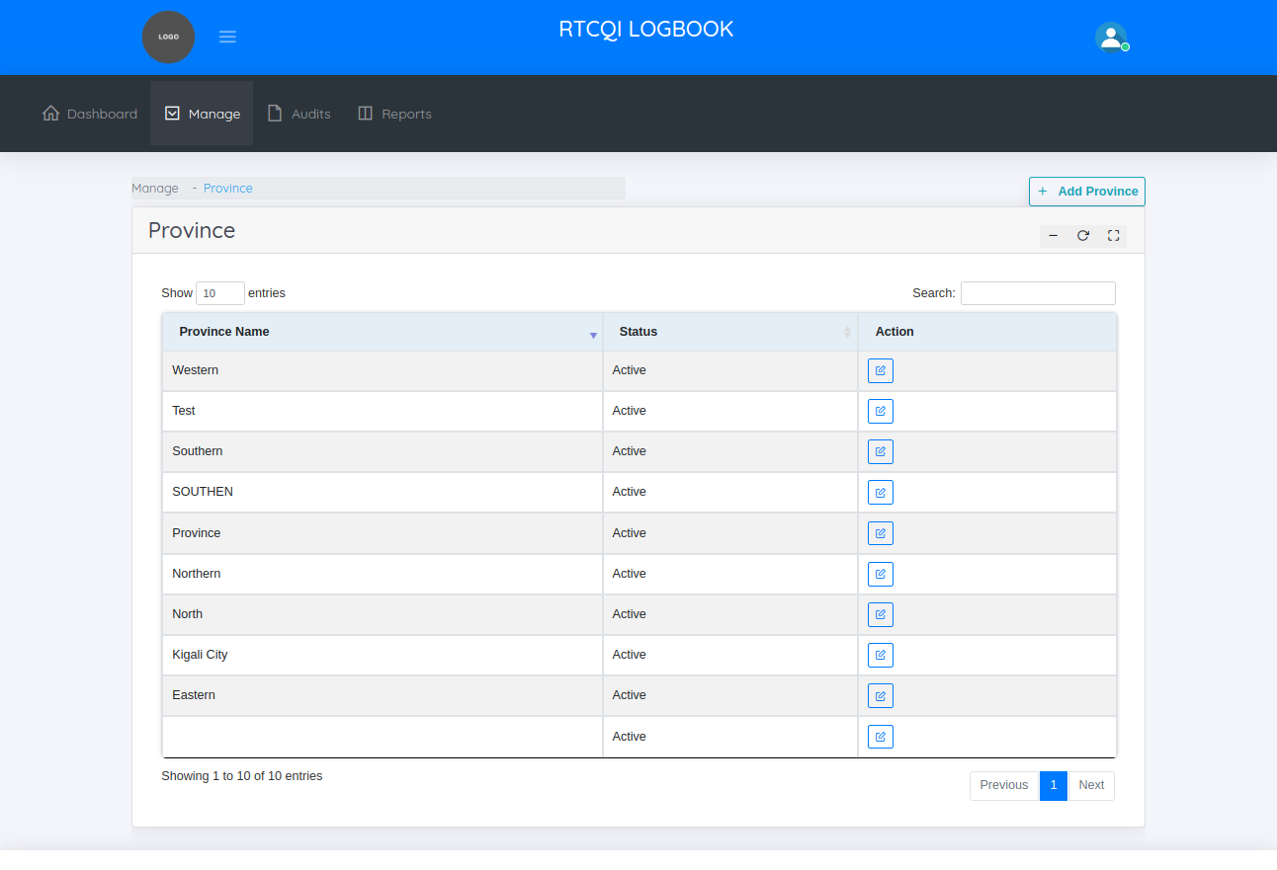

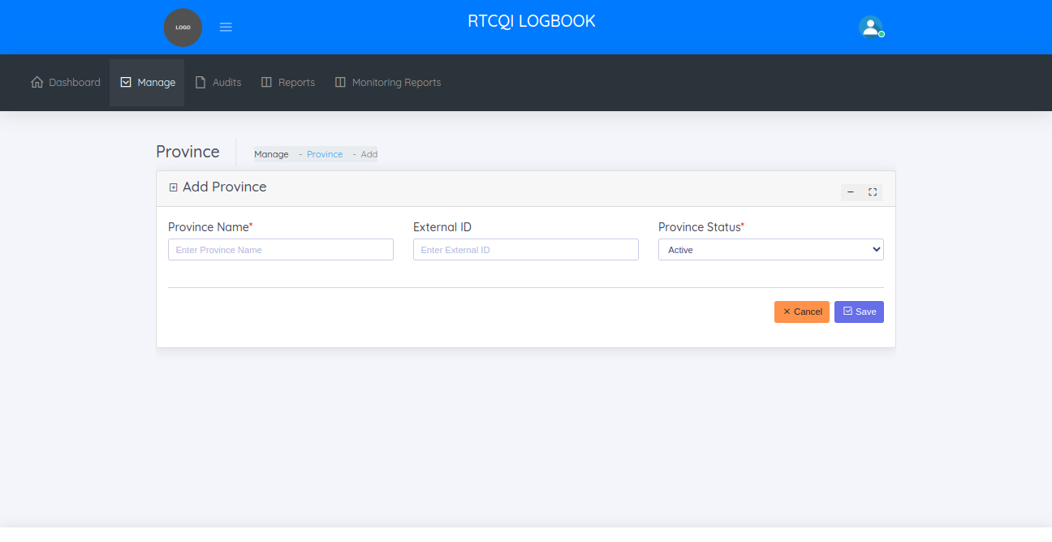

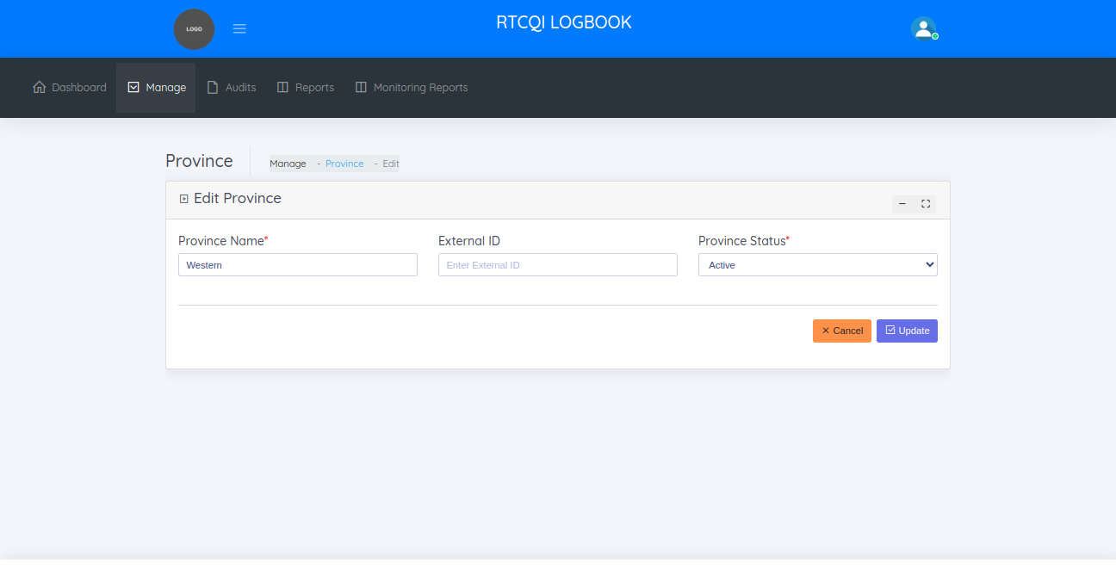

**DISTRICTS**

The distircts page helps to managing the various districts in the provinces

On the Districts page, the administrator can:

* + View districts
  + Add new district
  + Edit district

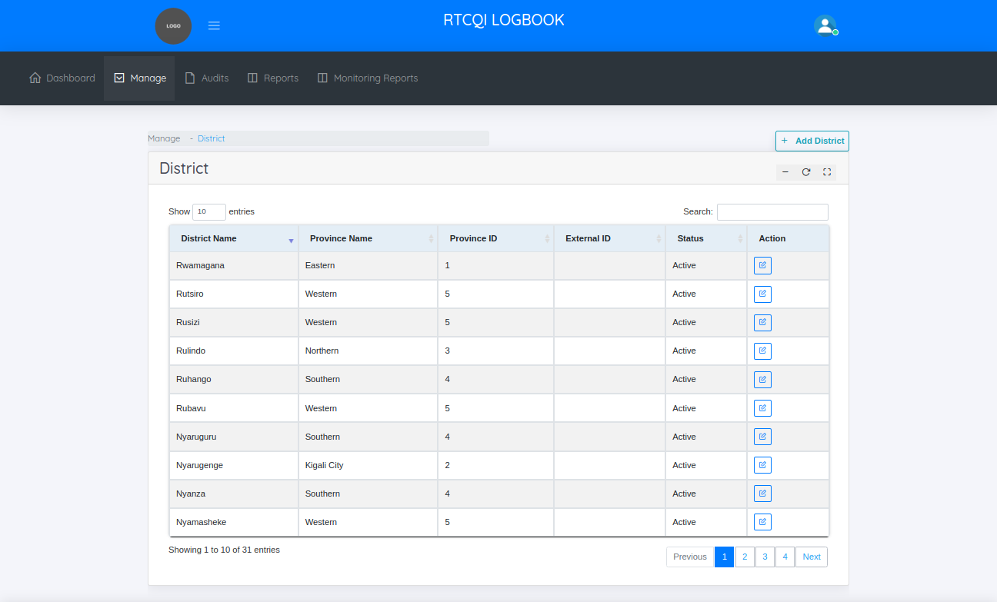

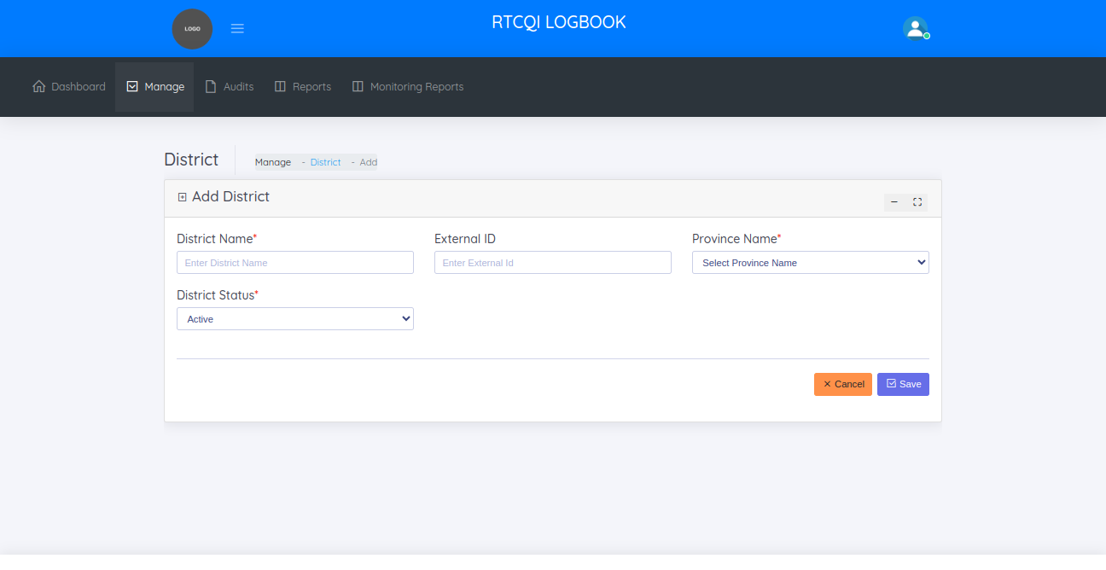

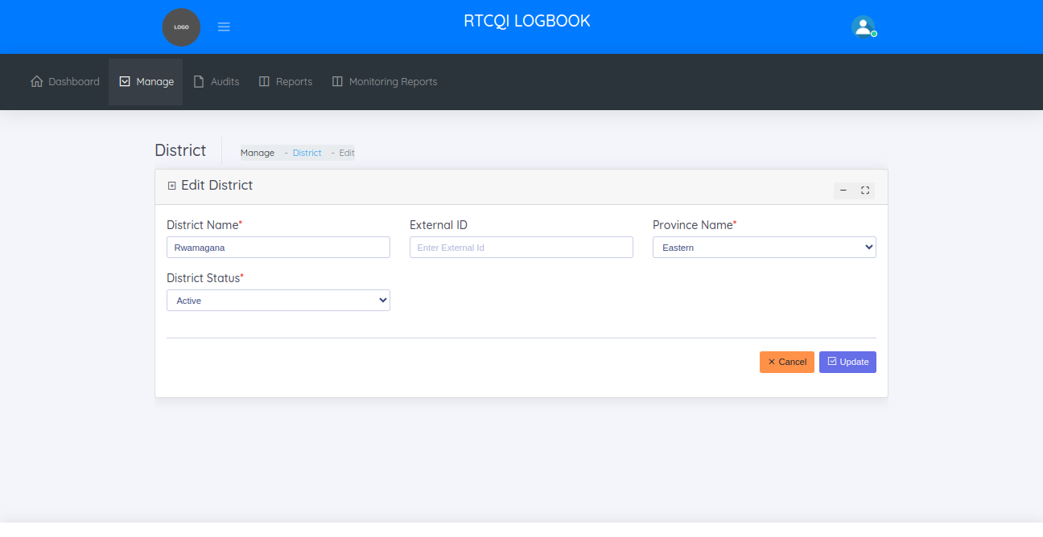

**SUB DISTRICTS**

The sub districts page helps to managing the various sub districts in the districts.

On the sub districts page, the administrator can:

* + View sub districts
  + Add new sub district
  + Edit sub district

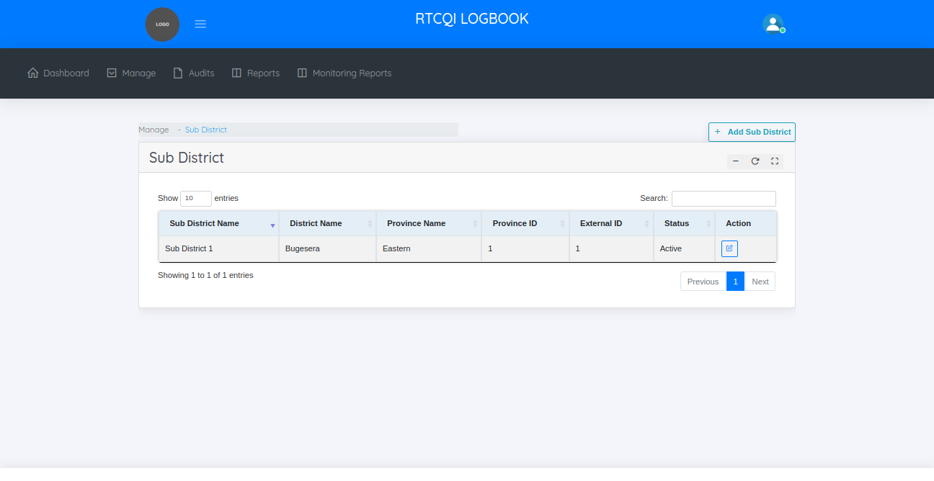

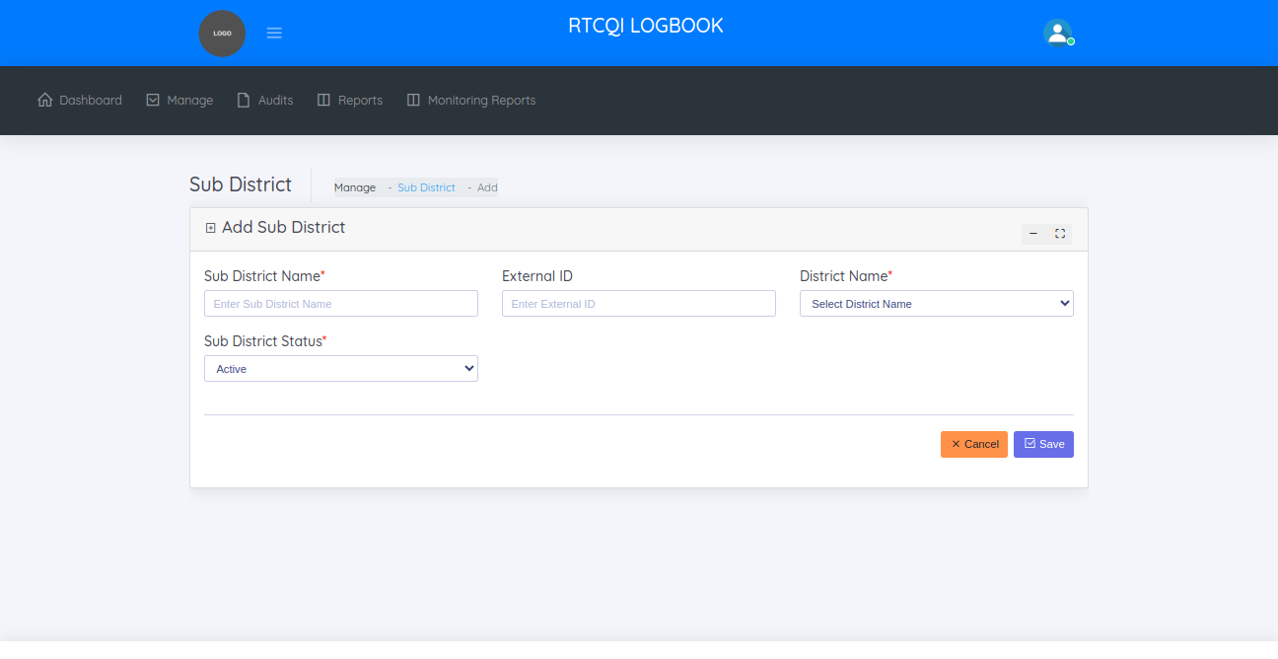

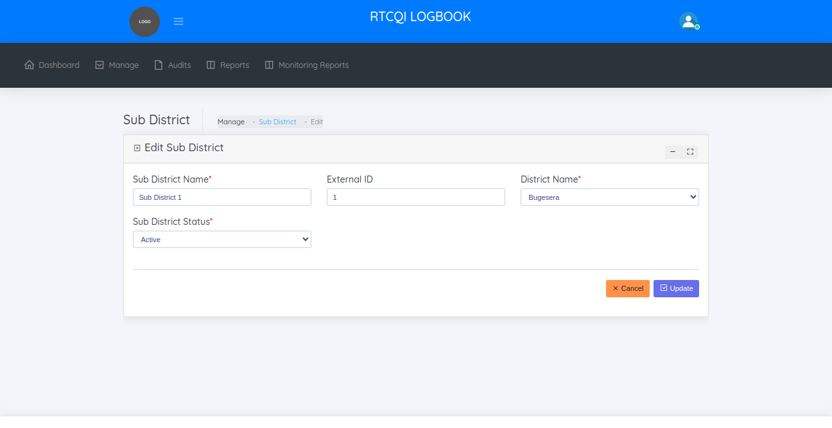

**GLOBAL CONFIGURATION**

This is the system default settings like instance name, institute name, admin name, admin email, admin phone, recency test, number of test, latitude, longitude, application title, map zoom level, testing algorithm, disable inactive users, no of months and logo

On this page, administrator can:

* + View Configuration Settings.
  + Edit Configuration Settings

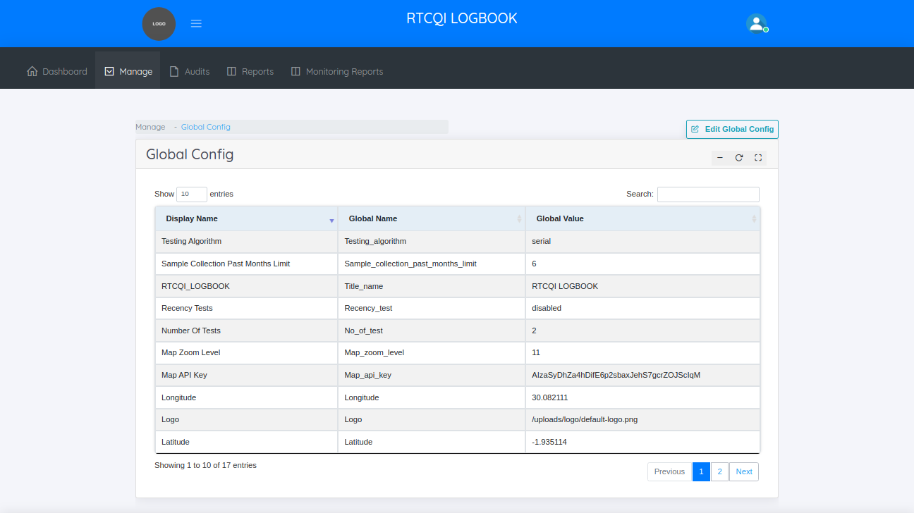

**EDIT GLOBAL CONFIGURATION**

In this page administrator can change these settings.

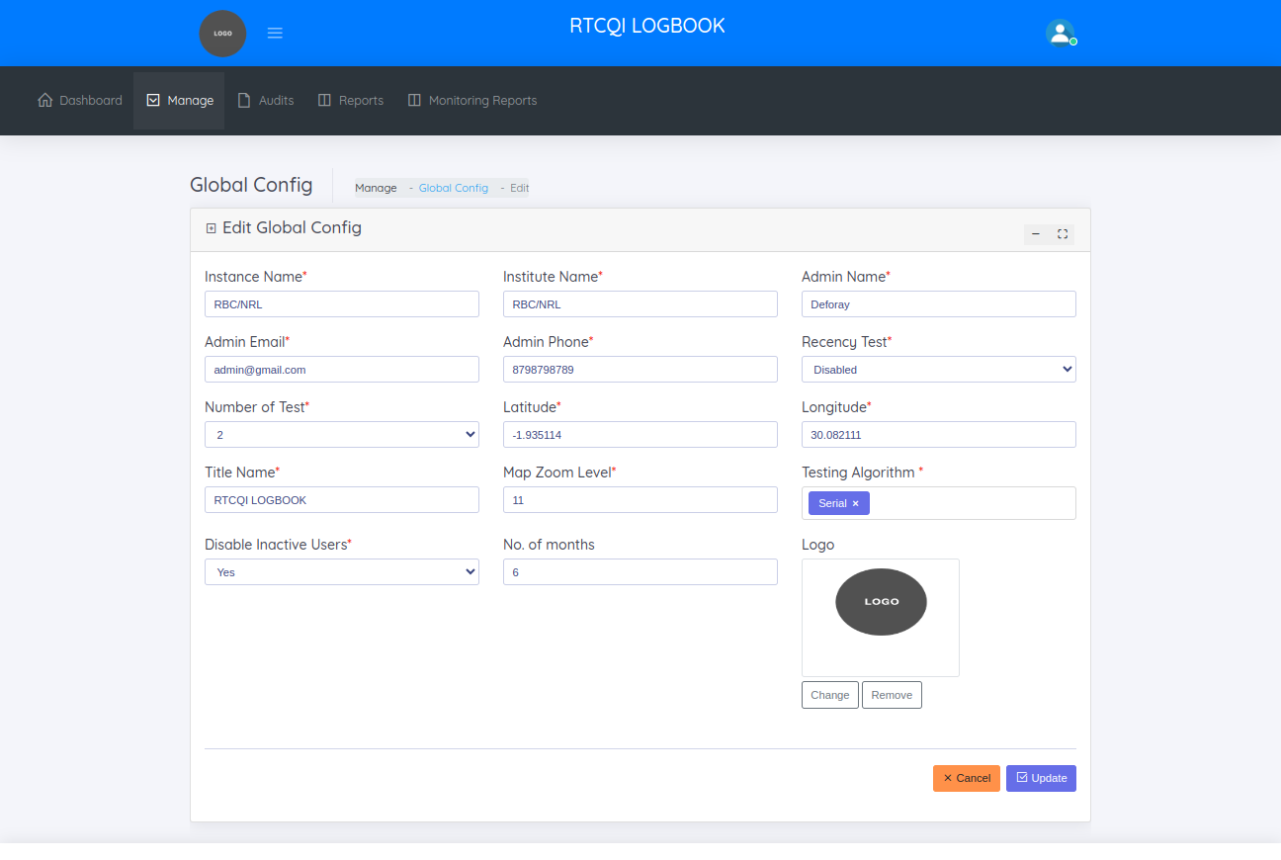

**SITE TYPES**

The site type helps to manage the site types.

On the site types page, the administrator can :

* + View entry Point / site types
  + Add new entry point / site type
  + Edit entry point / site type

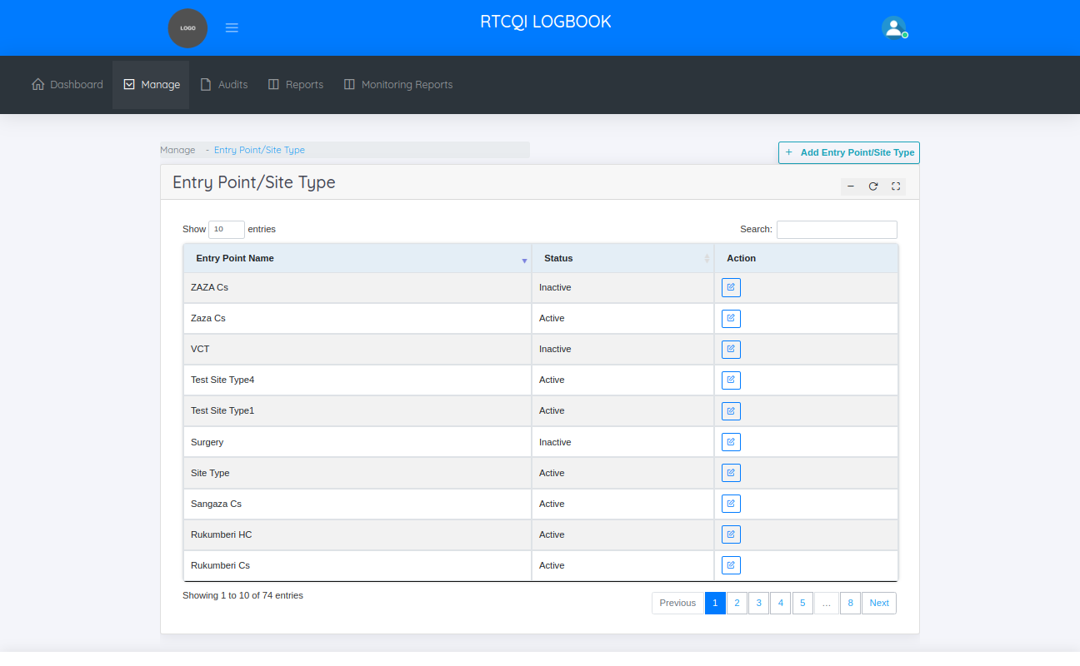

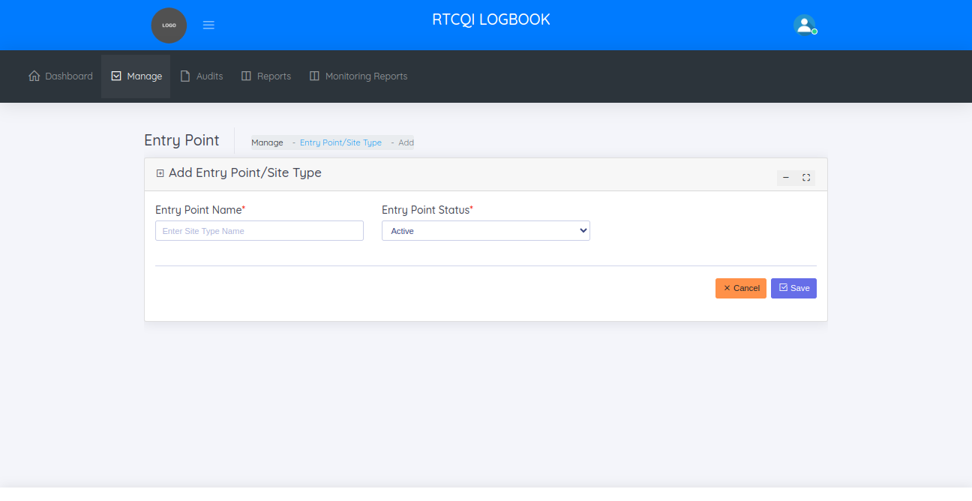

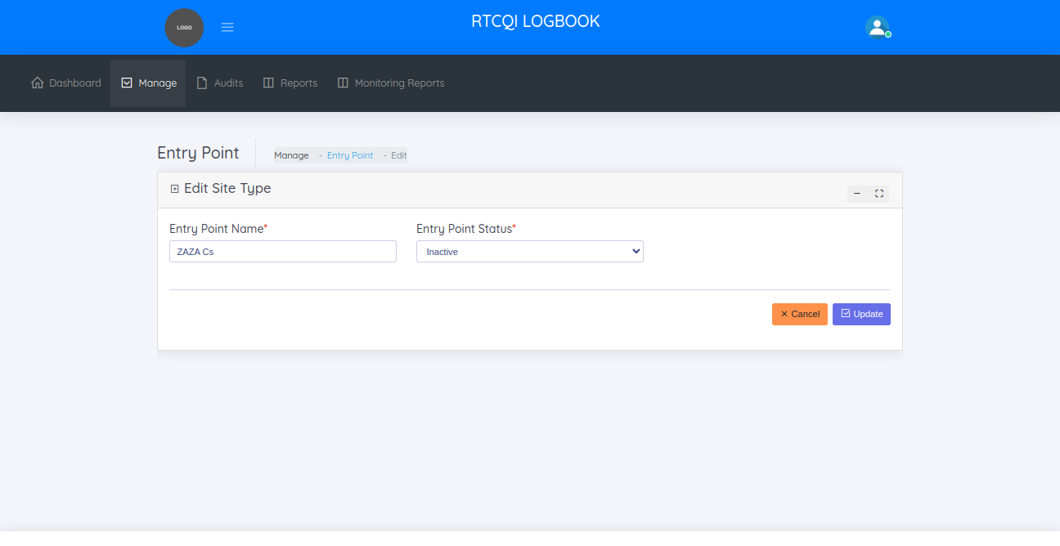

**TEST KIT**

The test kit helps to manage the test kit details like kit name, manufacturer, and kit name id

On the test kit page, the administrator can

* + View test kits
  + Add test kit
  + Edit test kit

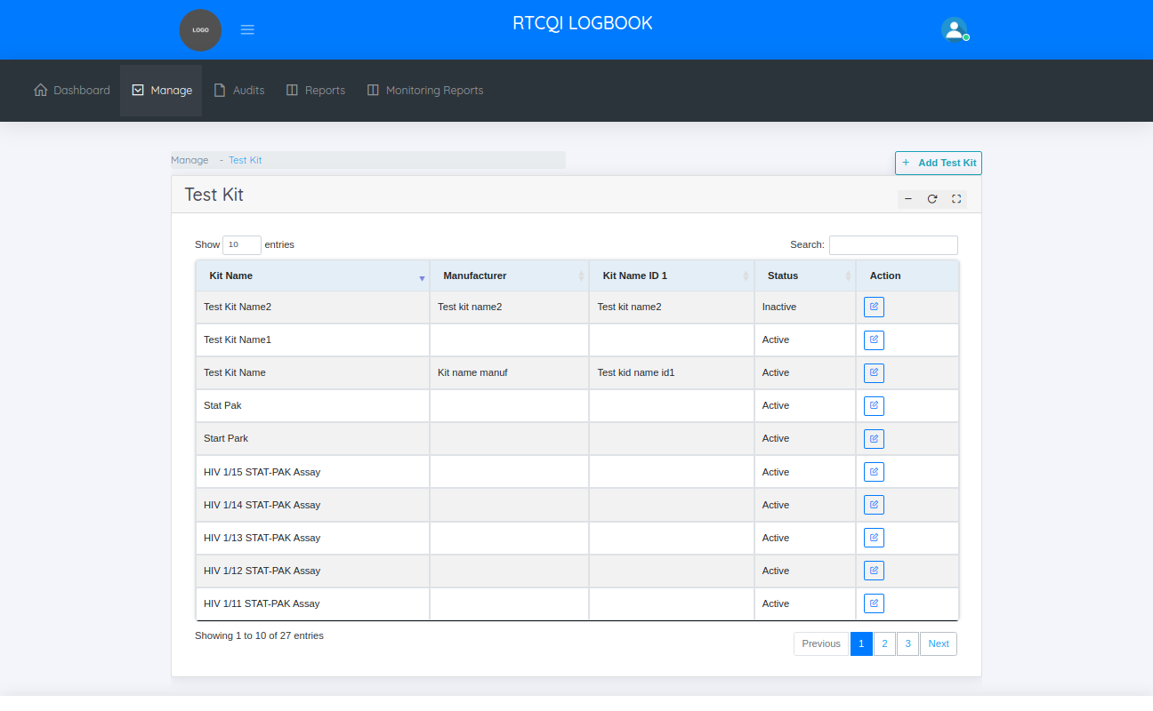

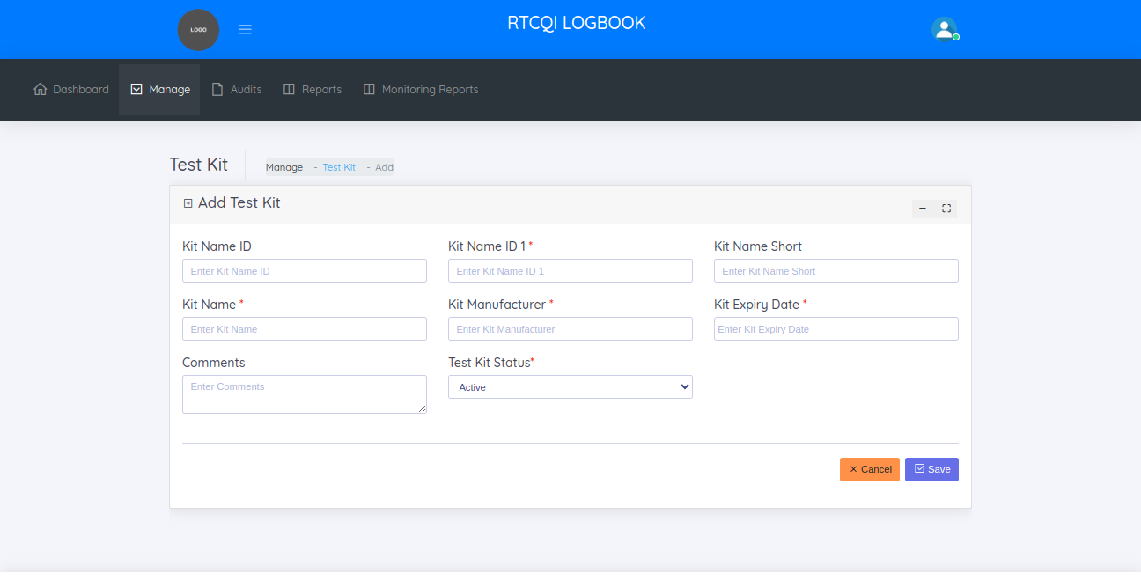

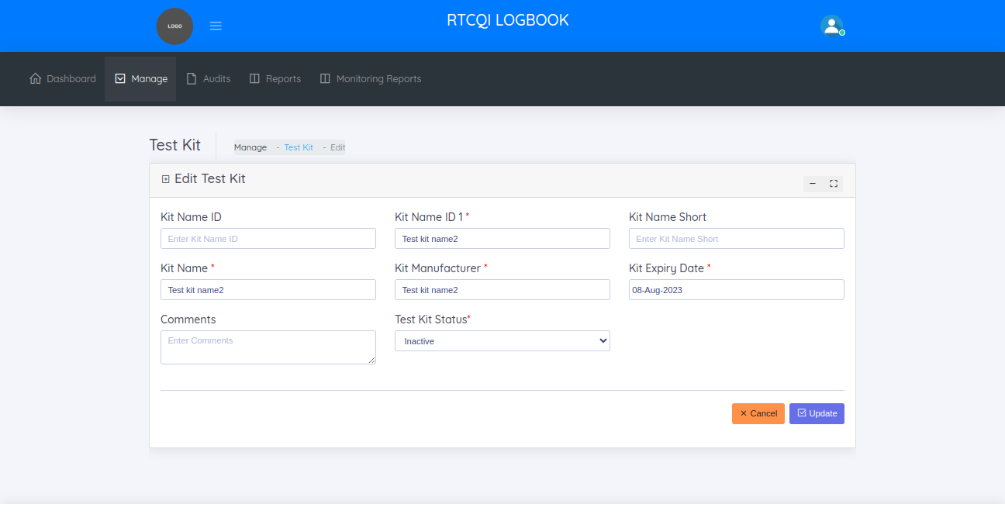

**ALLOWED TEST KIT**

The allowed test kit page helps in managing the allowed test kit details

On the allowed test kit page, the administrator can

* + View allowed test kits
  + Add allowed test kit
  + Edit allowed test kit

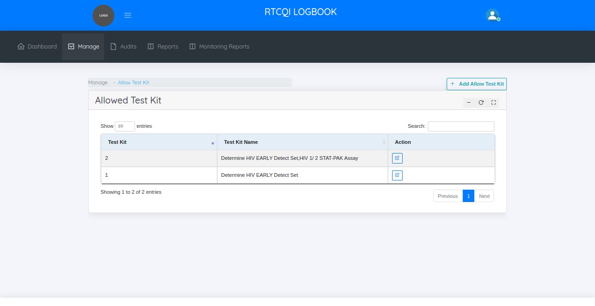

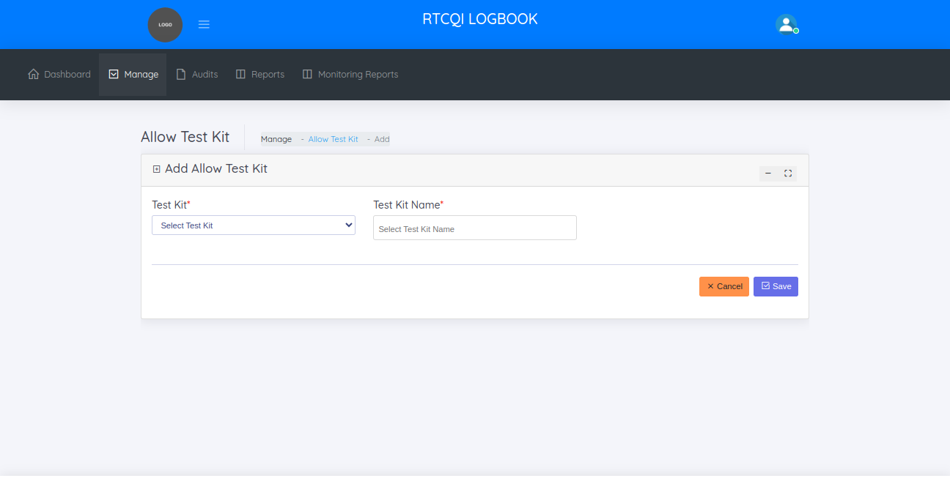

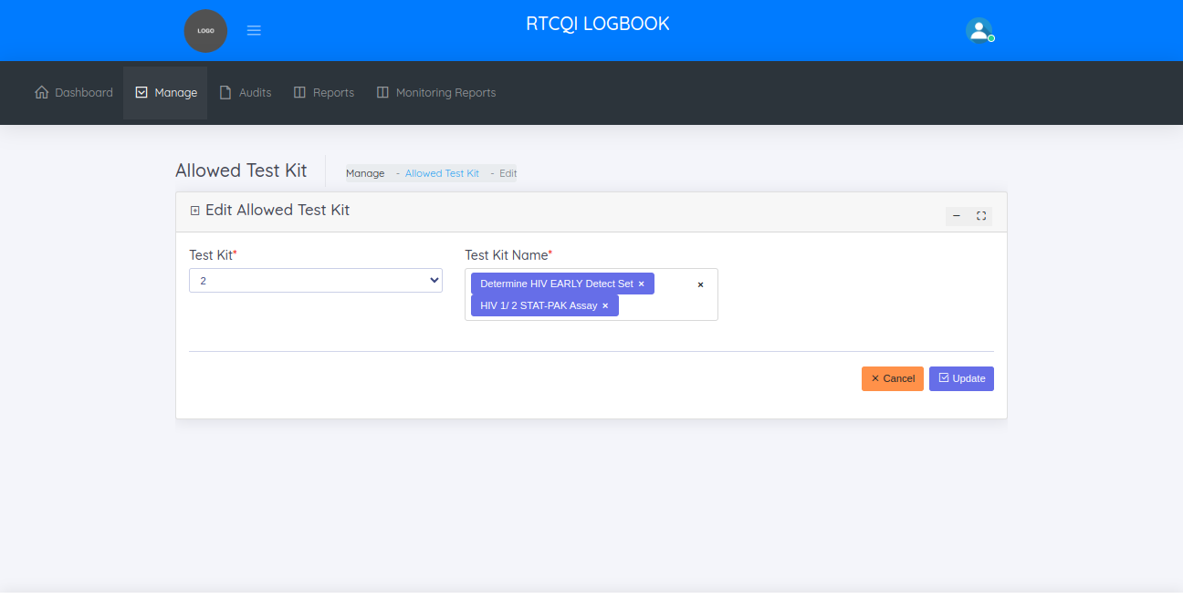

**AUDIT TRAIL**

The audit trail page helps to manage the history of monthly reports. It helps to know when monthly report was modified, how many column changed. This is the track of monthly reports.

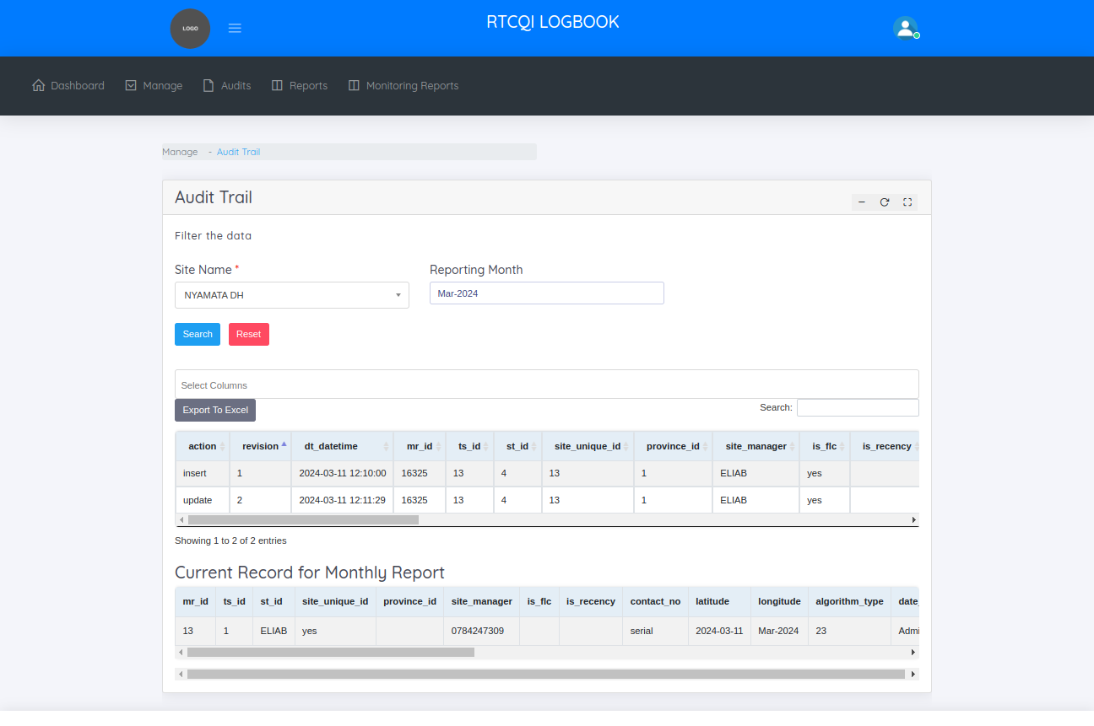

**Implementing Partners**

The implementing partners page helps to manage the partners.

On the implementing partners page, the administrator can

* + View implementing partners
  + Add implementing partners
  + Edit implementing partners

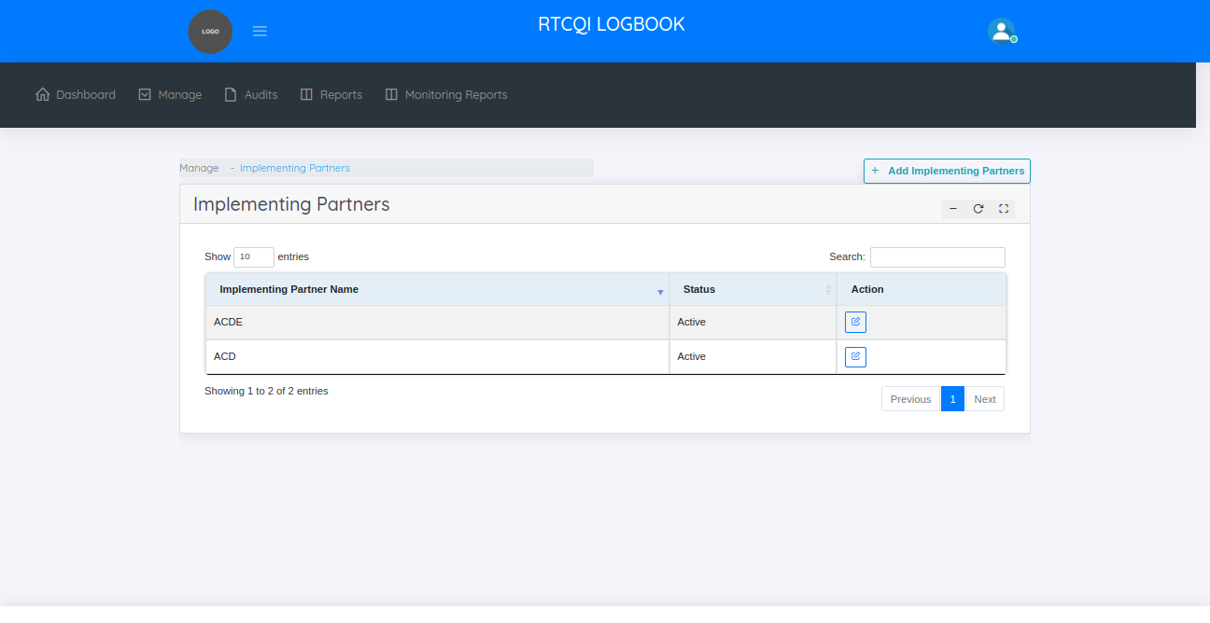

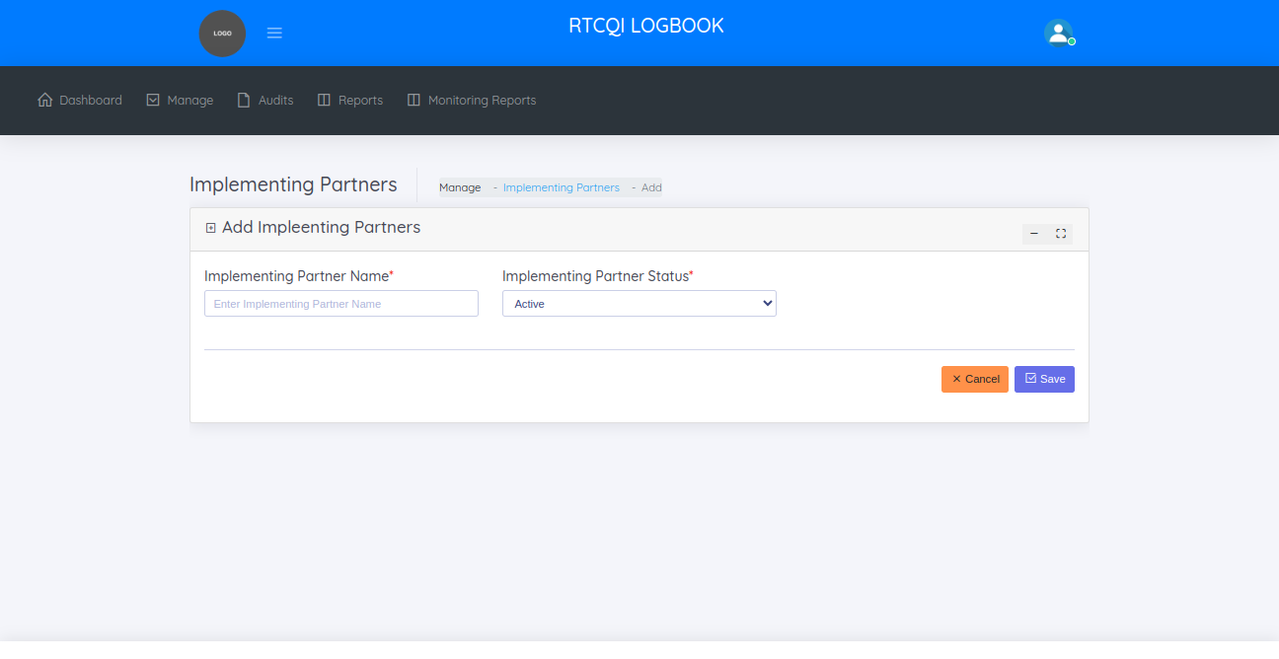

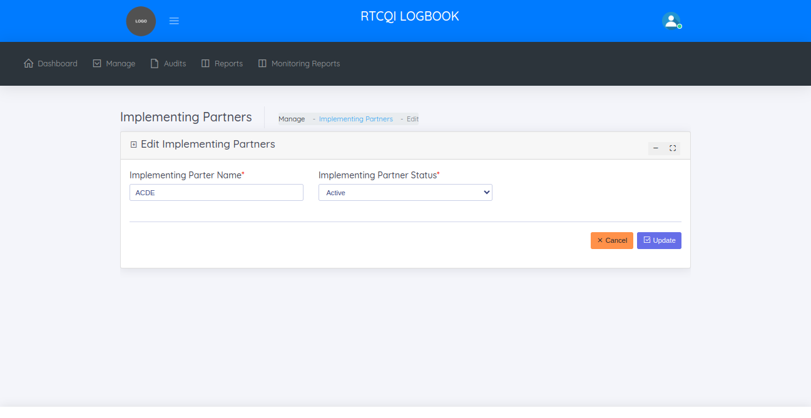

**AUDITS**

In audits menu, shows two sub categories

* + Monthly Reporting(Data Entry)
  + Failed Imports - Excel Upload

**MONTHLY REPORTING**

The monthly reports page helps to manage all monthly reports.

On the monthly reporting page, the administrator can

* + View Monthly Reports
  + Add Monthly Report
  + Edit Monthly Report
  + Bulk Upload Monthly Report

**VIEW MONTHLY REPORTS**

BY default, this page shows all the monthly reports of last 30 days. Filterwise also shows the reports like date range, province name, district name, sub district name, site name

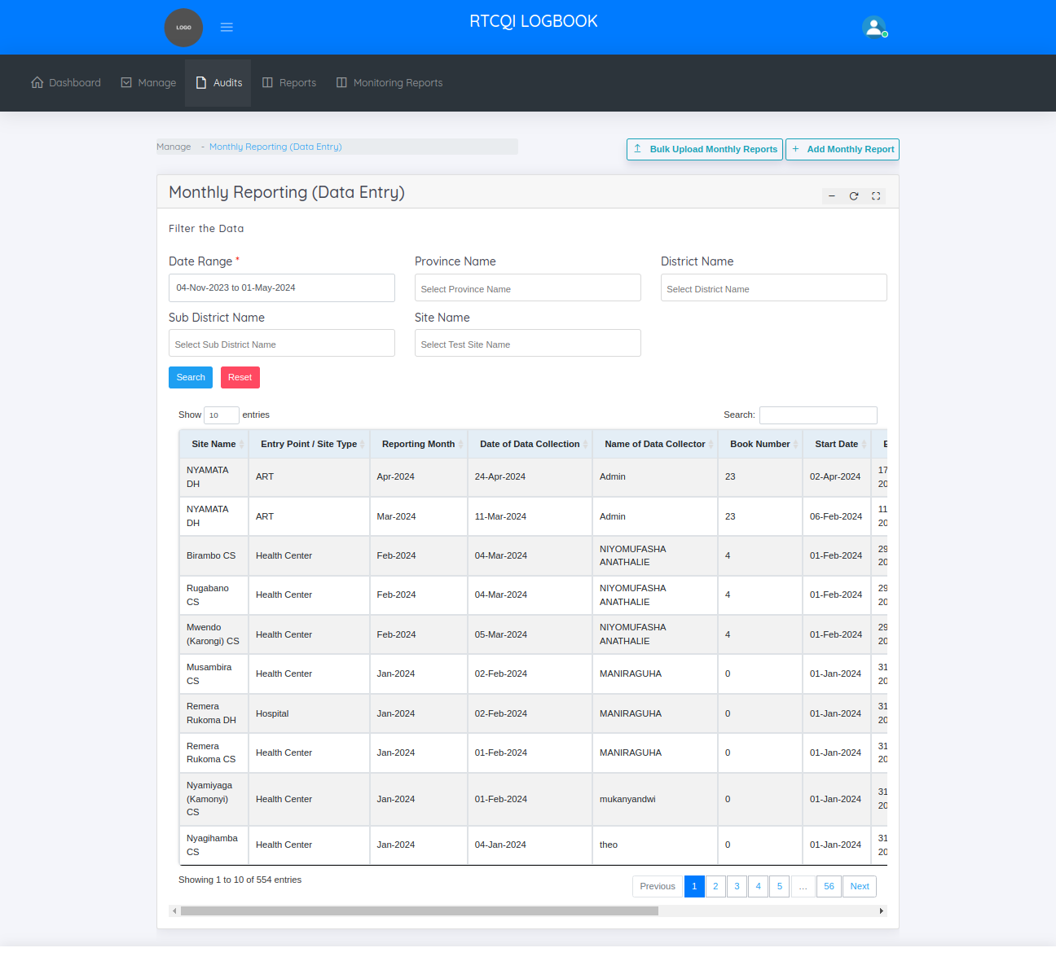

**ADD MONTHLY REPORT**

This is the add monthly reports page

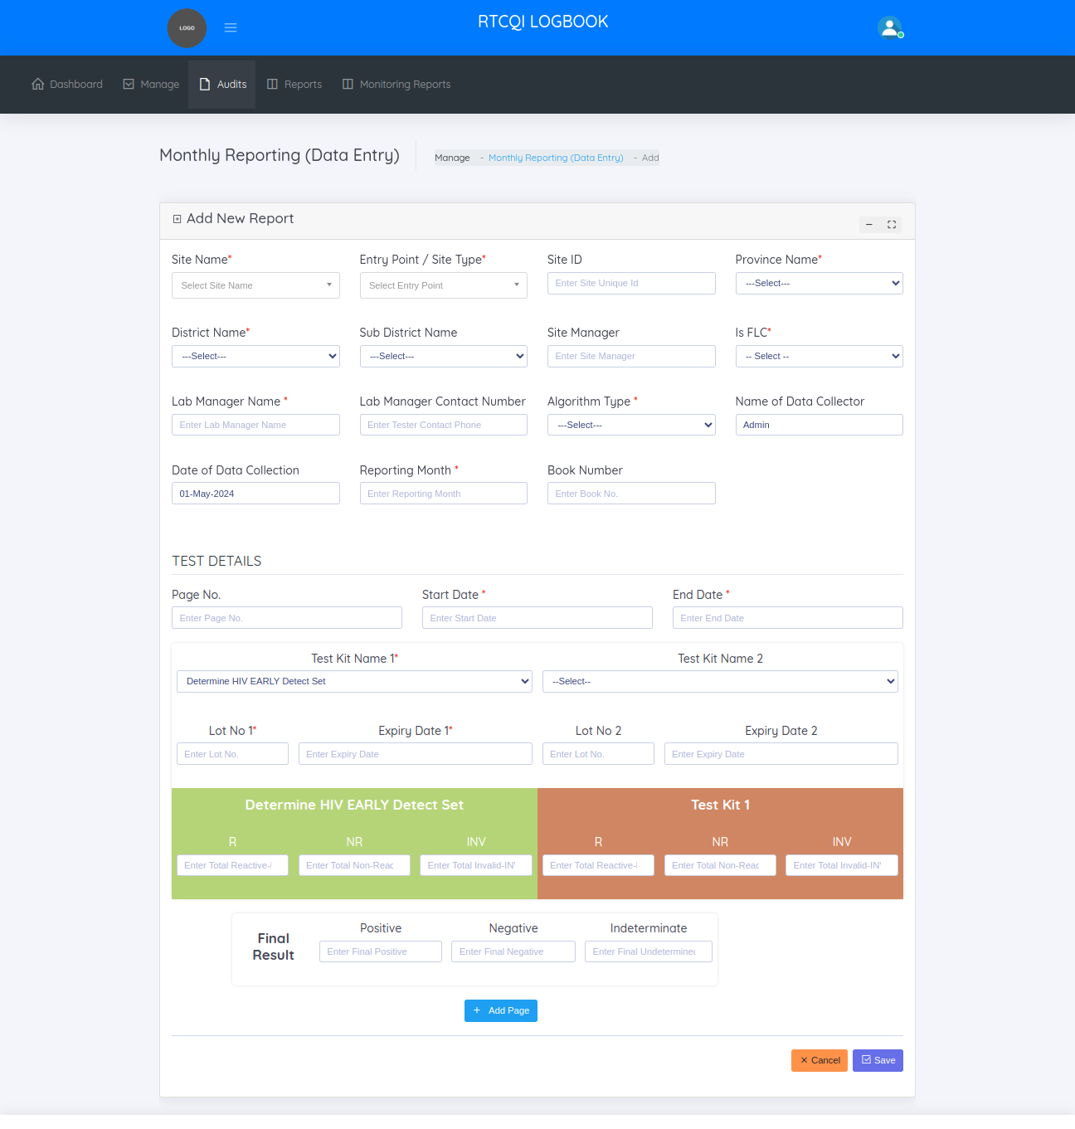

First select any of the site need to add monthly report, above the form shows recently added monthly reports for the selected site.

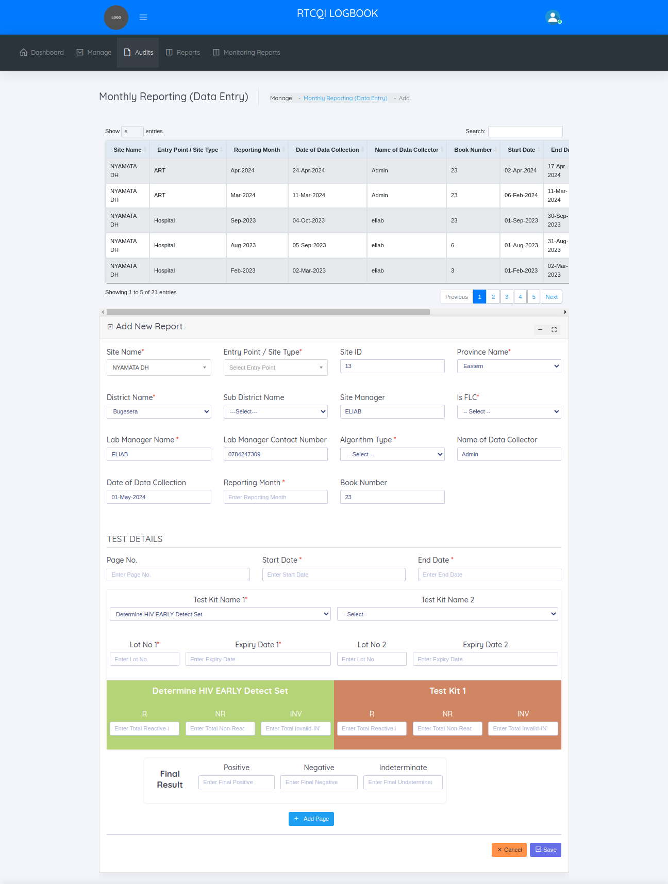

**EDIT MONTHLY REPORT**

This page helps to update if any changes needed in the already added monthly report.

Edit form below, shows the history of the report like when add, update. History grid we show the event type, action, resource, ip address, Date time.

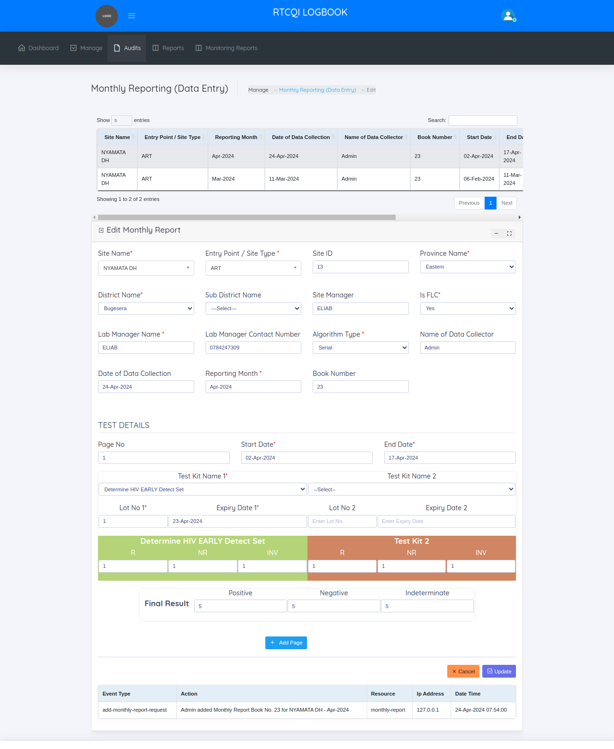

**BULK UPLOAD MONTHLY REPORTS**

This page helps to import multiple reports at a time. Follow the steps to import monthly report

1. Click the download sample monthly report excel sheet button ,there one sample monthly report excel sheet downloaded.
2. Enter the datas in the downloaded excel sheet
3. Choose the file
4. Click the Upload button

After upload display one success message ,

In that display message how many reports uploaded, then how many imported and how many not imported. Then the imported reports is display in the view monthly reports page. Failed imported reports view in the failed import monthly reports page

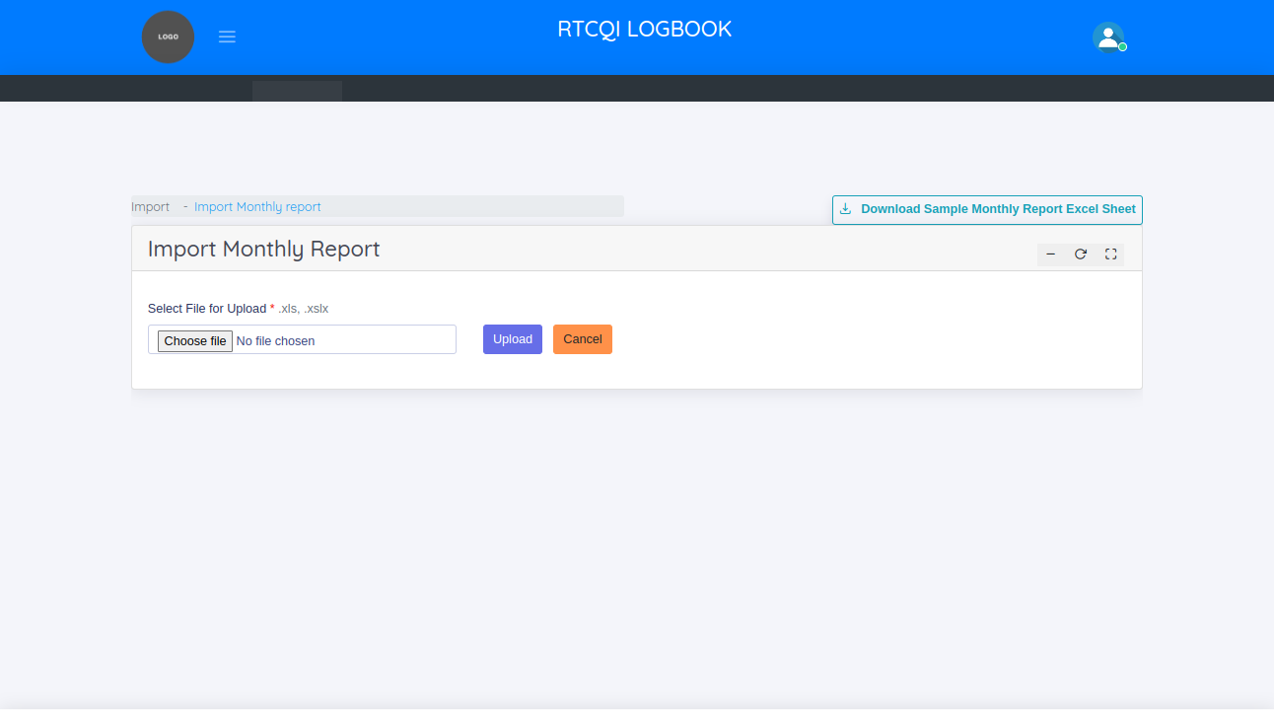

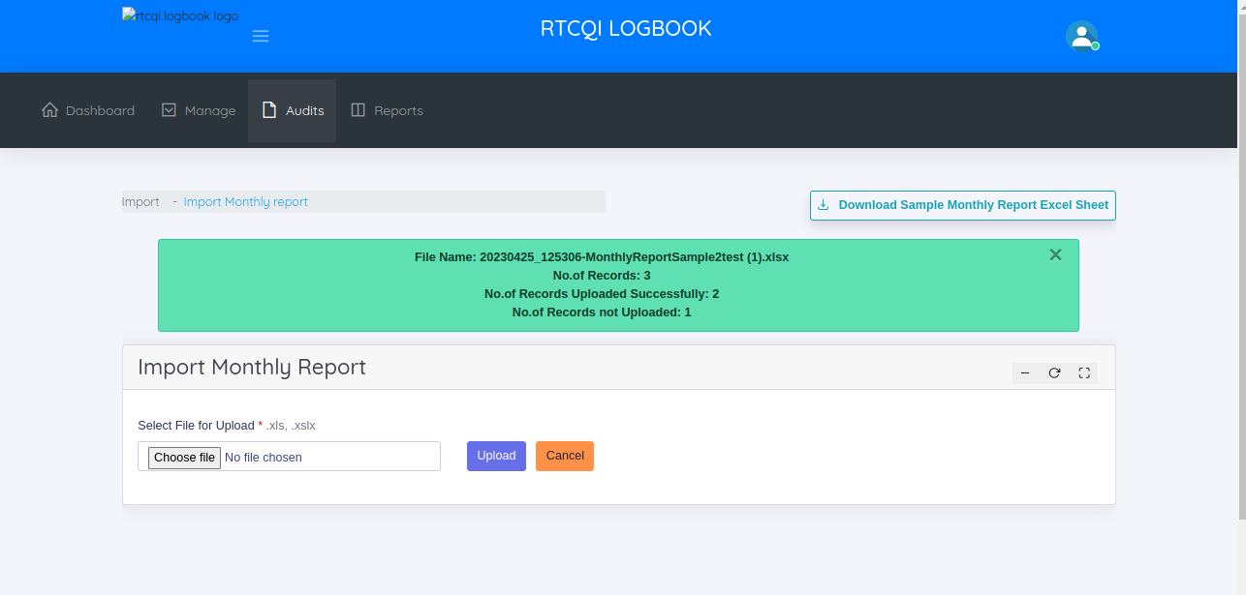

**FAILED IMPORTS - EXCEL UPLOAD**

This page helps to manage not uploaded monthly reports

In the failed imports - excel upload page, the administrator can

* + View Not uploaded Monthly Reports
  + Add Monthly Report
  + Bulk Upload Monthly Report

**VIEW NOT UPLOADED MONTHLY REPORTS**

This page shows the not uploaded monthly reports.

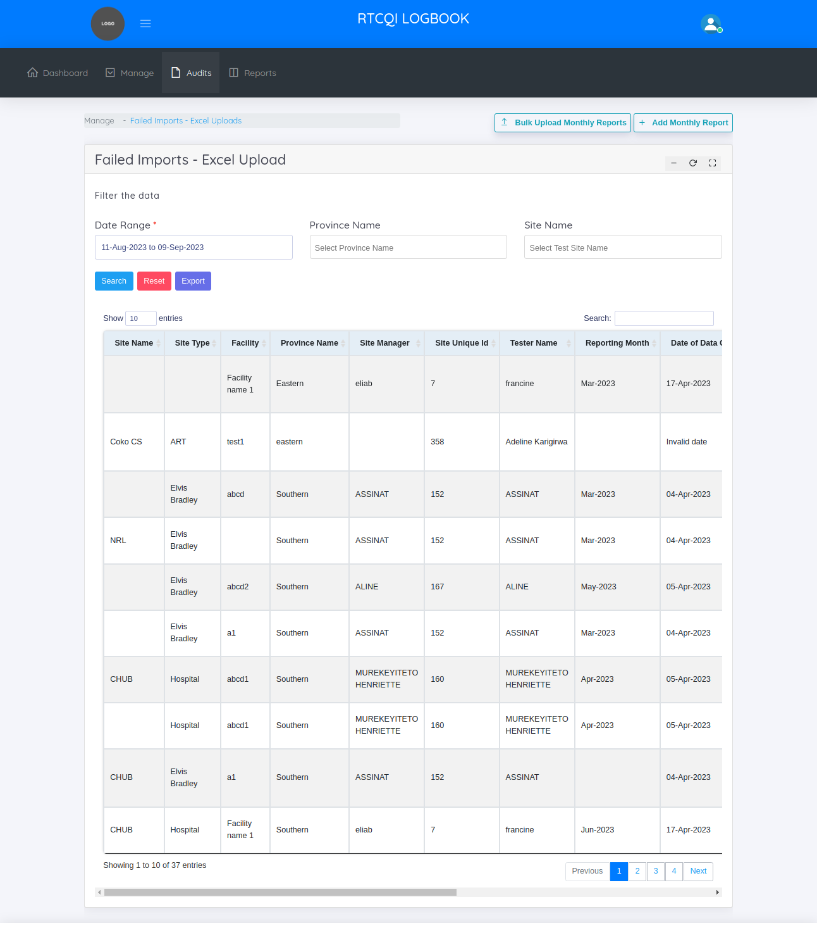

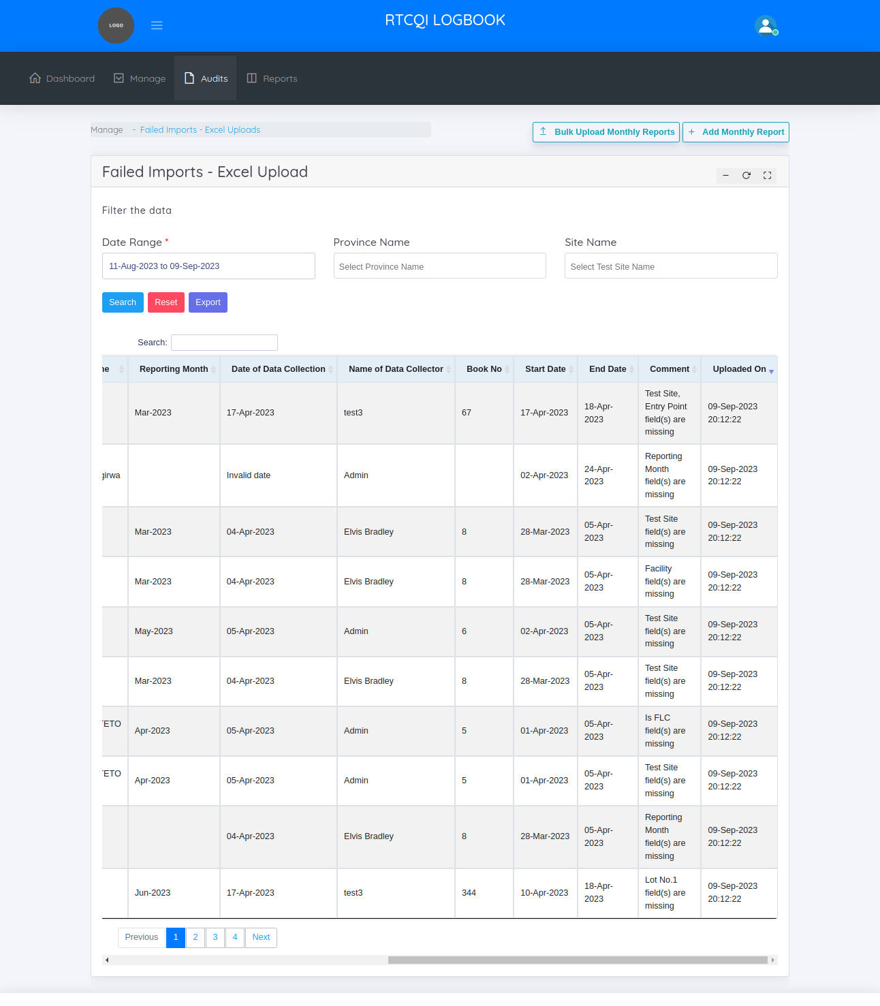

In the above screen shot, shows the comment column. The comment column mentioned, why the Report is not uploaded so easily find out the reason. Then export the data in the excel sheet using filters like date range, province name, site name then change/ miss the data as per the comment column then click the bulk upload button then just uploaded the excel sheet.

**REPORTS**

RTCQI Log Book shows 5 categories of reports.

* + Trend Report
  + Logbook Report
  + Test Kit Report
  + Invalid Result Report
  + Custom Report
  + Not Reported Sites

**TREND REPORT**

By default this page shows last 18 month report. This page helps to take a reports by filtering the data.

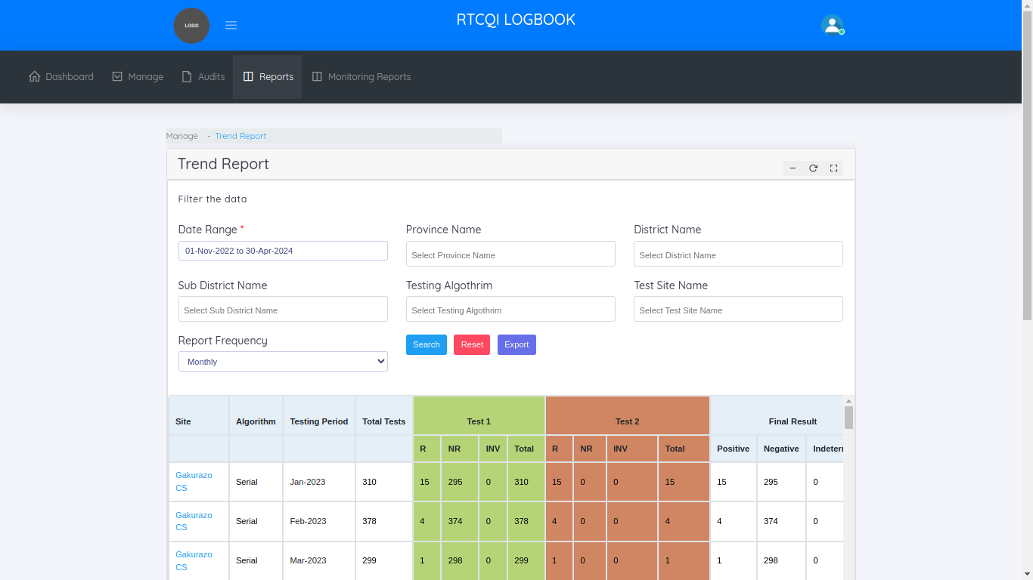

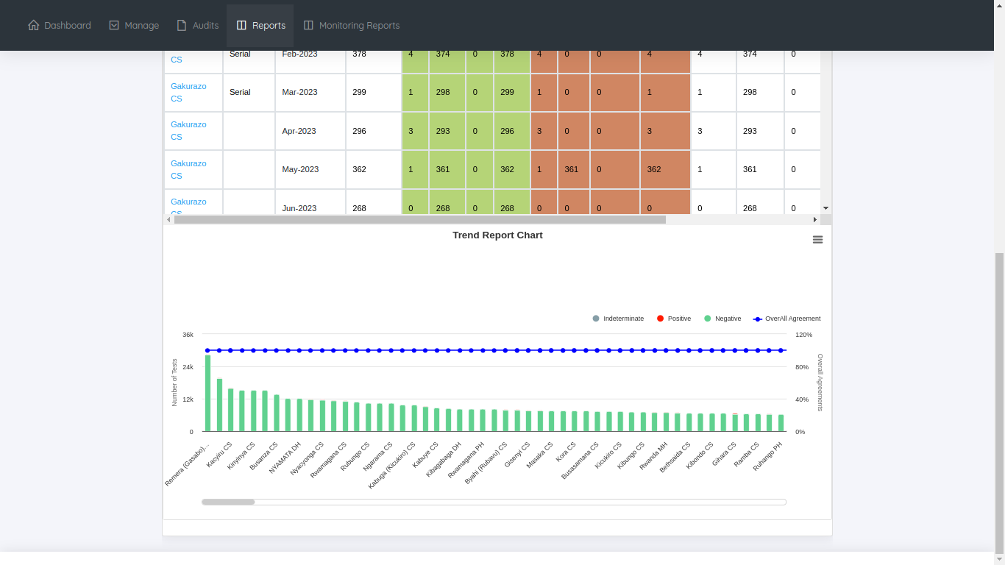

**LOG BOOK REPORT**

By default this page shows last 18 month report. This page helps to take a reports by filtering the data.

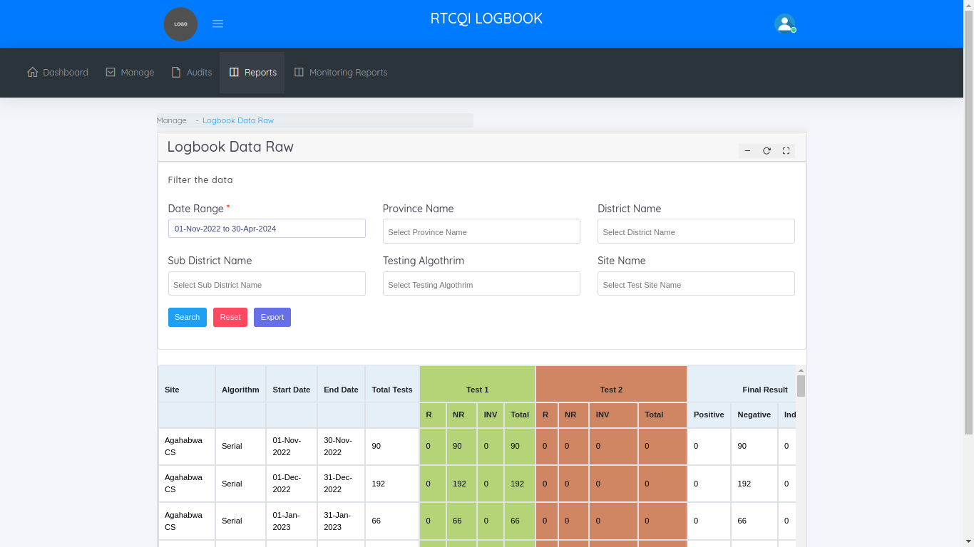

**TEST KIT REPORT**

By default this page shows last 18 month report. This page helps to take a reports by filtering the data.

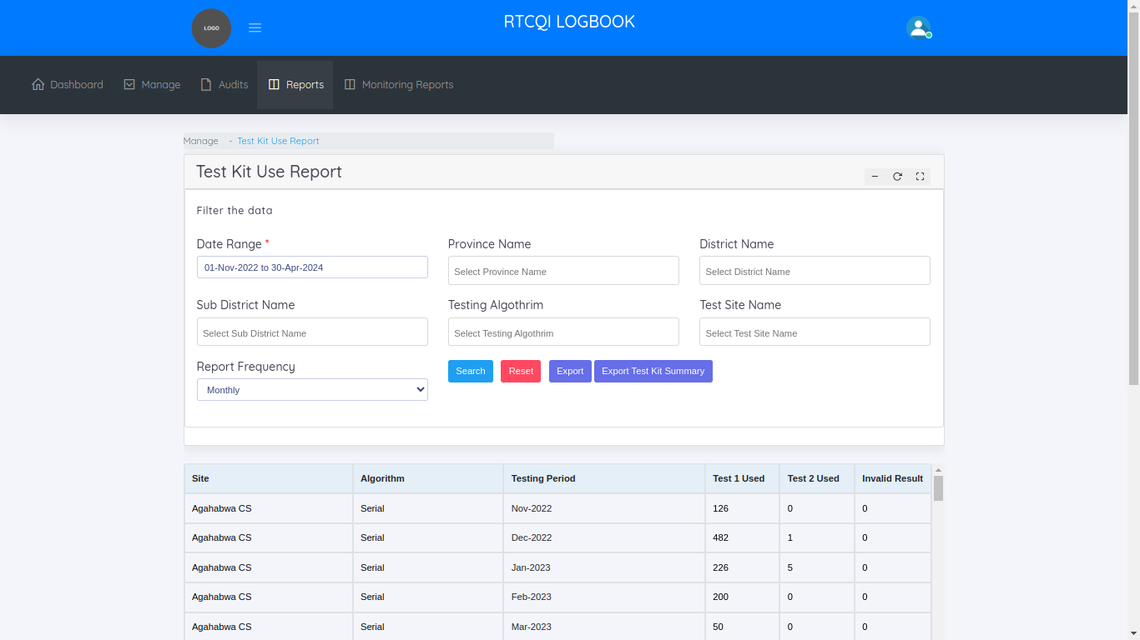

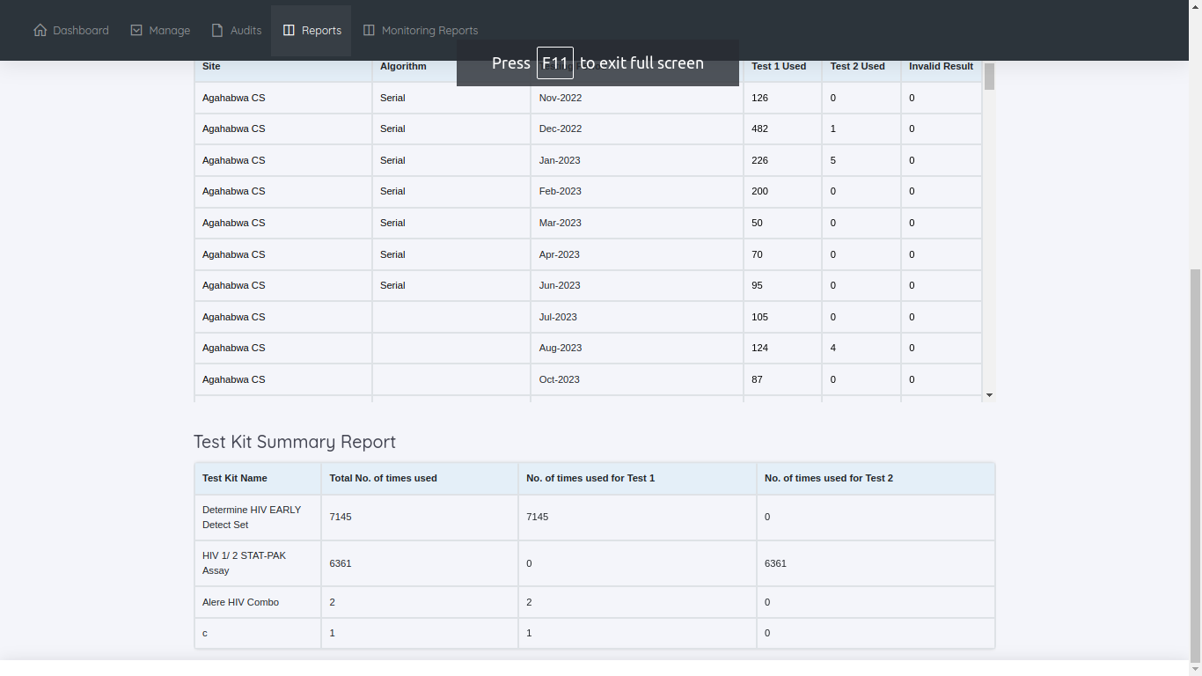

**INVALID RESULT REPORT**

By default this page shows last 18 month report. This page helps to take a reports by filtering the data.

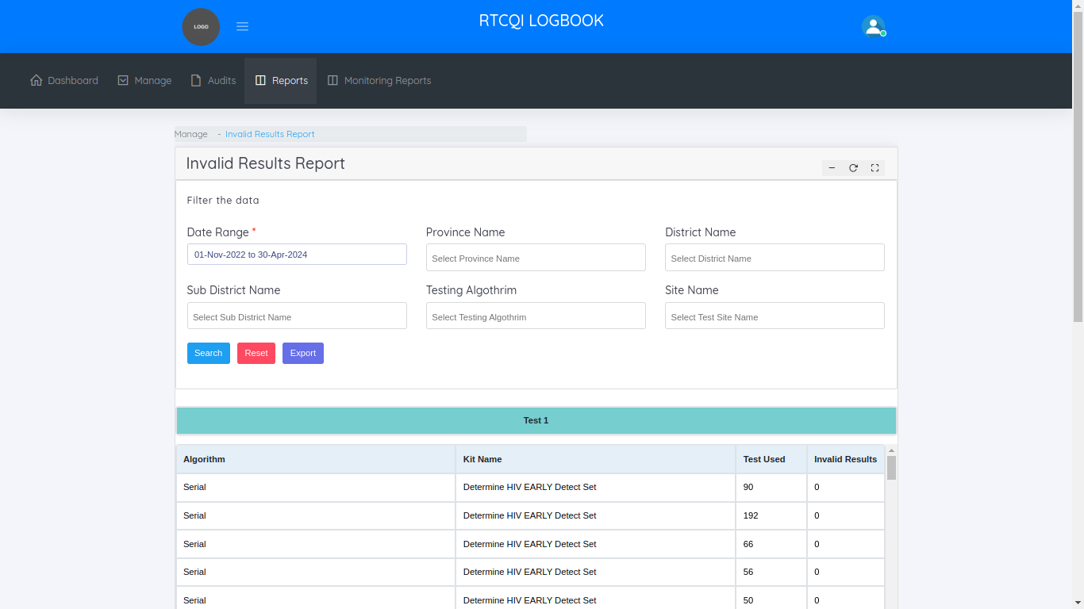

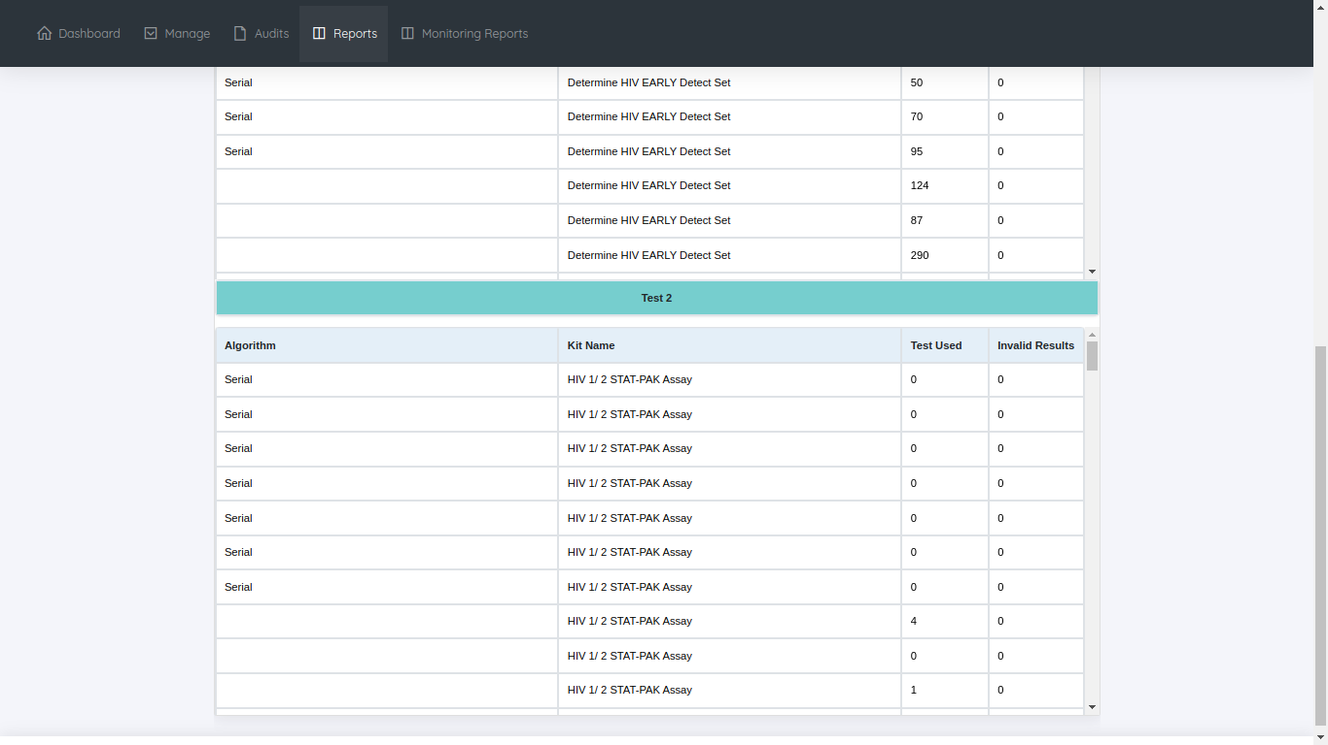

**CUSTOM REPORT**

By default this page shows last 18 month report. This page helps to take a reports by filtering the data.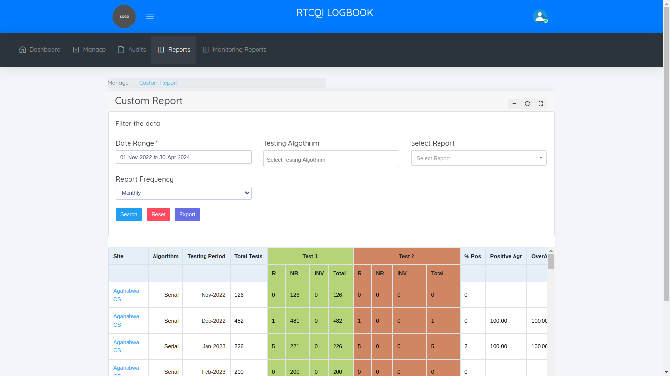

**NOT REPORTED SITES REPORT**

By default this page shows last 18 month report. This page helps to take a reports by filtering the data. Not reported sites we get for the particular Date Range.

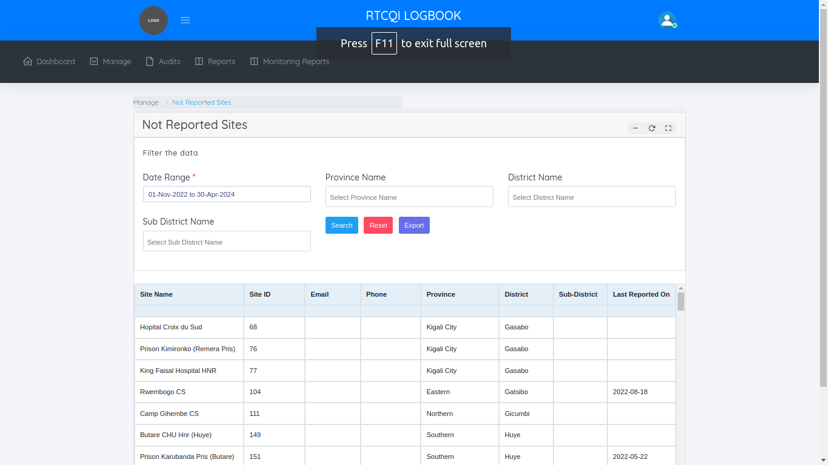

**Monitoring Reports**

In monitoring reports menu, shows one sub category

* + Site-Wise Reports

**Site-Wise Reports**

This page helps to manage the site wise monitoring monthly reports. By Default we show last 18 months monitoring report. We know, How many monthly reports we added per month for the particular site and how many total emails we sent to the particular sites.

Cross icon means not adding any monthly reports for the reporting month. Tick icon means added the monthly reports for the particular month. We mouse over the tick symbol we know the count of monthly reports.

